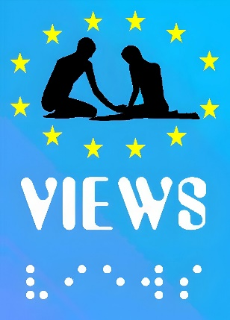

Annual Report 2025
  - VIEWS International
  - Version: December 2025

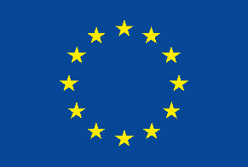 | This publication has received financial support from the European Union. The information contained in this publication does not necessarily reflect the official position of the European Commission.

Table of Contents
Table of Contents 1
Introduction 3
Our Team 4
The Board of Administrators 4
The Executive Office 4
Our Partners 5
Our Activities 6
European Solidarity Corps projects 6
Inclusion for All 6
ACT-YOU 7
The Big Thing 8
VIPPSTAR 9
Four new projects 10
Language Tandems 10
Awareness-raising Activities 11
External Representation 13
Document credits 14

Introduction

VIEWS International
Visually Impaired Education and Work Support (VIEWS International) is European NGO that promotes the international mobility and independence of young persons with visual impairments.
The main goals of Views International are:
- to facilitate positive and fruitful exchanges between sighted and visually impaired young Europeans;
- to facilitate the integration of youth with visual impairments in the social and professional life, and encourage their independent living;
- to build on the values of solidarity and democracy, that are specific of the European culture.
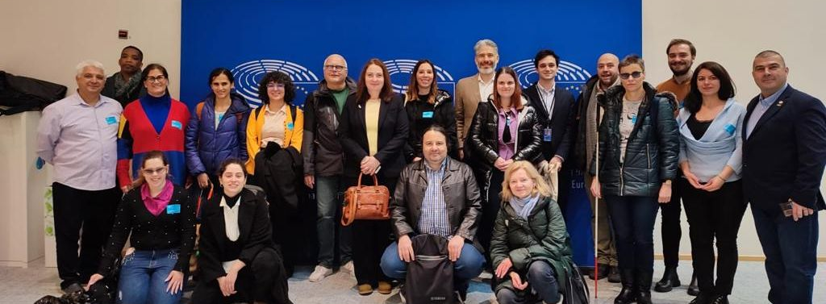
From 2008, we strive to give the opportunity to young visually impaired people to develop and build strong skills, enhance their autonomy and make international experiences by:
- Raising awareness about EU Youth Strategy through the design and implementation of unique adapted youth mobility projects (debates, seminars, youth exchanges), adapted volunteering-placements abroad, awareness raising sessions concerning the living conditions of visually impaired persons to equip our beneficiaries with intercultural experiences, lingual knowledge, digital skills, social competencies and other soft skills. The aim is to prepare them for the labour market and to be actively integrated and involved in the social and cultural life;
- Promoting the opportunities of the Erasmus+ and European Solidarity Corps programmes and making them available, accessible and attractive to visually impaired young people.

Our Team
VIEWS International is composed by a team of European visually impaired or sighted people who are involved in youth projects (volunteering, seminars, training, debates, strategic partnerships, etc.). It represents organisations across Europe (from around 20 European countries) working on different projects for and with young visually impaired people, with the aim of fostering their social and personal empowerment.

Board of Administrators
The organisation is run by a Board of Administrators (BOA) composed of 4 visually impaired members representing Belgium, Italy and Turkey. The BOA works closely with the Executive office in order to set up the organisation’s strategy and implement the activities decided by the members during the annual General Assembly.
Currently, the members of the Board of Administrators are:
- Sylvie Doyen, President
- Adil Ahmet Kavrama, Delegated Adminstrator
- Elif Kain, Secretary
- Michael Pellegrino, Treasurer

Executive Office
The Executive office of the ENGO is based in Liège, Belgium, and it employs two full-time and two part-time employees. Our team is composed of:
- Anca David, Executive Director
- Jean-Paul Venuto, Administrative Assistant
- Carmen Todorut, Project Manager
- Giulia D’Agnolo, Communications Officer and Junior Project Manager

Our Partners
Together with partners from all over Europe, VIEWS International works on various youth projects in the framework of E+ and ESC programmes to contribute to the implementation of the EU Youth Strategy.
This year, we collaborated on several projects with:
Loryhan, Belgium
Sakura, Romania
Babilon Travel NGO, Romania
Nyílj meg!" Autizmussal Élőkért Alapítványt, Hungary
Art House, Armenia
Asociación Arkhe, Spain
Zavod ODTIZ, Slovenia
Peace Volunteering Network, Albania
Peace Volunteering Network Norway
Slovenian Association of Disabled Students, Slovenia
Polish Association of the Blind, Poland
CuBu Foundation, Bulgaria
Spolek PELICAN, Czechia
AMILLA NPO, Greece
Social Welfare Center of Thessaly Region, Greece
OECON Group, Greece
ANONIMI ETAIREIA EREVNAS, Greece
I.E.R.F.O.P. ONLUS, Italy
Odòs Cooperativa Sociale, Italy
eMundus, Lithuania
Fundacja Imago, Poland
Fundacja InfluEDU, Poland
Ofensiva Tinerilor, Romania
Fundación Docete Omnes, Spain
Velorecicla, Spain
UICI Firenze, Italy
Università degli Studi di Brescia, Italy
LIGHT S.C.A R.L., Italy
Azienda Socio-Sanitaria Territoriale Spedali Civili di Brescia, Italy
Katholieke Universiteit Leuven, Belgium
Eberhard Karls Universität Tübingen, Germany
Università degli Studi di Trento, Italy
Spindox Labs SRL, Italy
Comftech SRL, Italy
University of Limerick, Ireland
Centrul Republican de Reabilitare pentru Copii, Moldova
The University of Edinburgh, United Kingdom
University of Ioannina, Greece
Istituto Superiore di Sanità, Italy
Eodyne Systems SL, Spain
Real Eyes Sport ASD, Italy
Erasmus Universitair Medisch Centrum Rotterdam, Netherlands

Our Activities

European Solidarity Corps projects
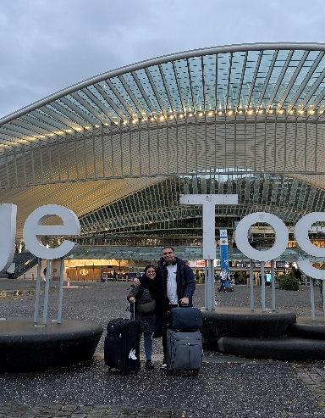
Promotion and facilitation of volunteering opportunities within Erasmus+ and European Solidarity Corps programmes to visually impaired young people is a core activity that VIEWS carries out every year to increase the inclusion of VIPs within society and promote a positive and fruitful exchange between sighted and visually impaired youth.
In 2025, we hosted four ESC volunteers, two in the VIEWS International office, Katel and Sofia, and two in the framework of a project with the Coordination Socio-Culturelle Sainte Marguerite, Youssef and Silviu.
Sofia and Silviu, who joined us in October 2025, will collaborate with us, La Baraka and the Coordination also next year.
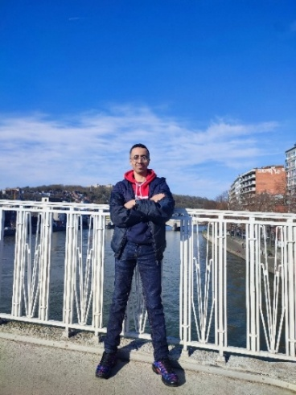
In the time they spent with us, volunteers had the opportunity to exercise and develop their communication skills and creativity, as well as their independence and social integration, by participating in and organising awareness-raising activities, language courses and external representation activities at the local, national and European level. The volunteers are also introduced to the organisation’s work, mobility sessions and French language courses.
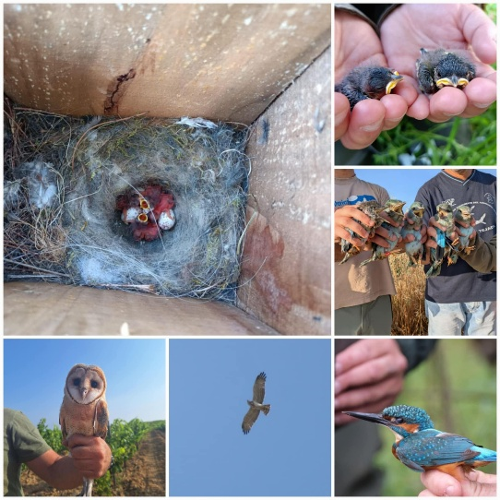
This year, we also sent two Belgian volunteers on ESC experiences abroad: Lorie travelled to Andalucia, Spain, to collaborate with SEO/Birdlife on the preservation of birds and conservation of their ecosystem. Caroline, instead, opted for a project in the Netherlands with the LavaLegato association. She is currently volunteering in a biodynamic farm called “Urtica de Vijfsprong”, where she carries out activities in the open air with employees and volunteers with intellectual disabilities.

Inclusion for All
All our activities foster the development of intercultural understanding, exchange between blind and sighted youngsters, the use of non-formal learning methods, the knowledge and discussion about important European issues like solidarity, equal opportunities, respect of diversity and inclusion.
In 2025, VIEWS International concluded the implementation of the Inclusion for All in Youth Work (I4ALL) project by organising a transnational training course focused on inclusive youth work practices and sustainability. In late March 2025, youth workers from Belgium, Hungary, Romania and Armenia gathered in Botassart, Belgium, at the premises of Loryhan, in a welcoming and participatory setting surrounded by nature.
From 24 to 30 March, participants took part in interactive workshops, outdoor activities and study visits exploring inclusion in youth work beyond disability, as well as ways to mainstream environmental awareness into their actions. The programme combined reflection, practical tools and shared experiences, creating space for learning, exchange and collaboration. The training course also offered participants the opportunity to develop project ideas and strengthen their confidence and engagement in inclusive youth work at local and European level.
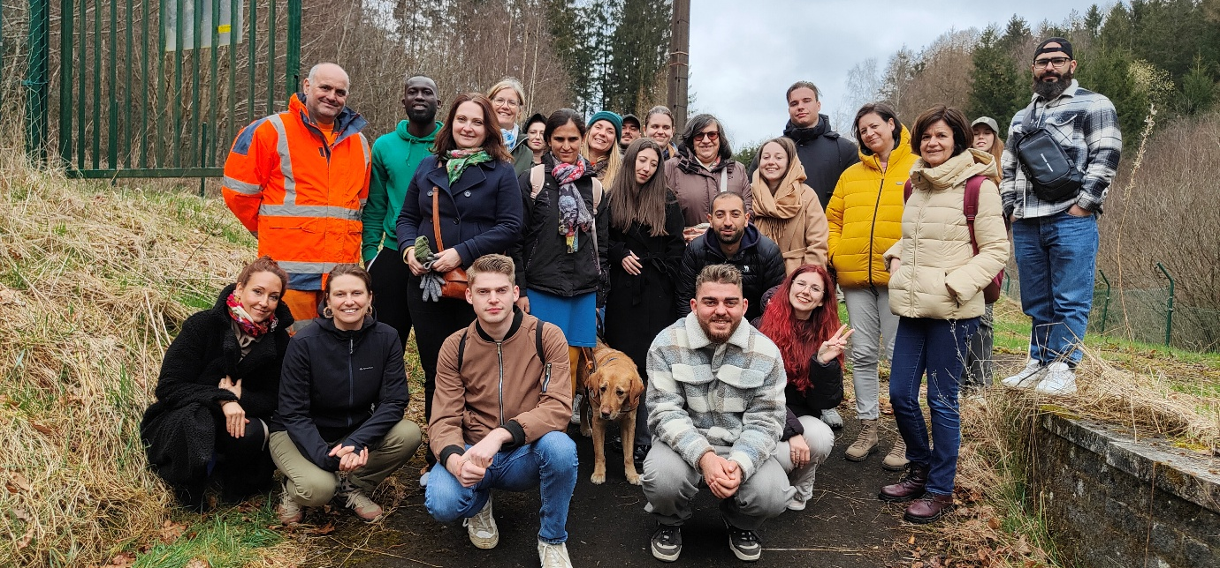

The Big Thing
2025 also saw the conclusion of The Big Thing project, which aimed to train people with disabilities from three countries as European trainers, using the European Training Strategy (ETS) competency model, and create a framework to help institutions include people with disabilities in their training activities
In the project’s final phase, we focused on consolidating results and ensuring their long-term use.
Throughout the year, partners finalised two sets of guidelines: one addressed to trainers with disabilities and one addressed to organisations wishing to develop more inclusive training activities. Based on the European Training Strategy competency model, these resources provide practical guidance for organisations working in youth training at national and European level.
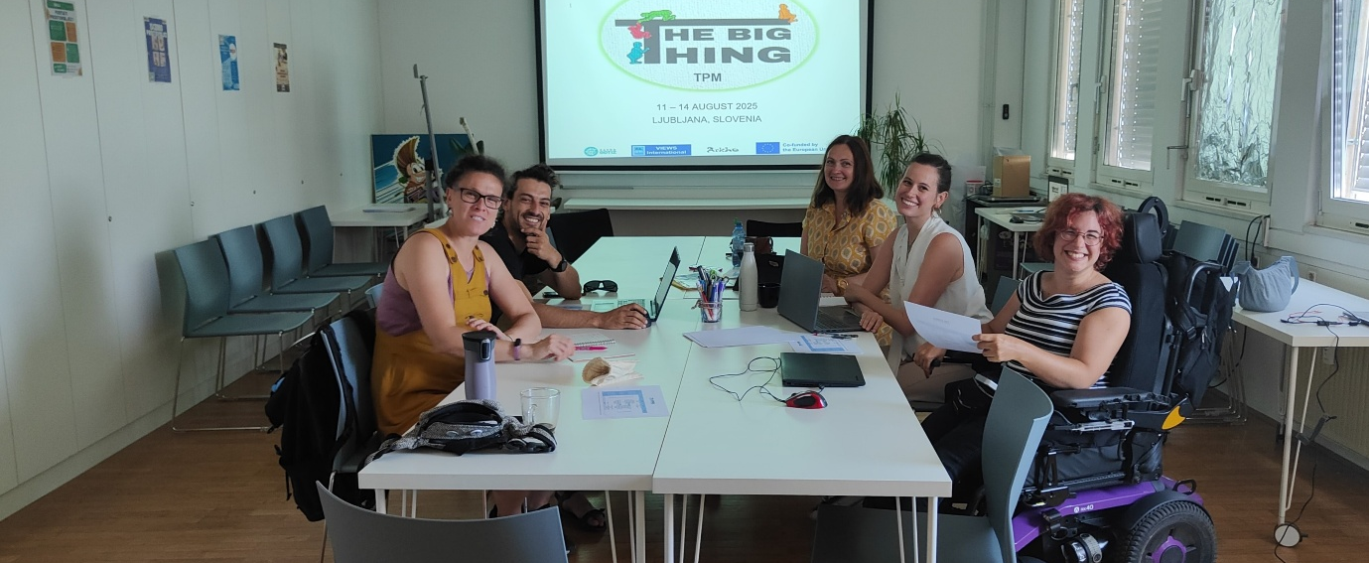
In August 2025, we met with our partners in Ljubljana, Slovenia, for the project’s final transnational meeting. The two-day meeting provided the opportunity to walk through the various phases of the project, evaluate its impact on the participants, trainers and staff alike, collect the lessons learnt and plan the partnership’s final steps.

ACT-YOU
The ACT-YOU project started in 2025 with the aim of supporting youth workers in creating inclusive and accessible environments for young people with fewer opportunities. The project promotes peer learning, exchange of experiences, and the development of practical skills for inclusive youth engagement.
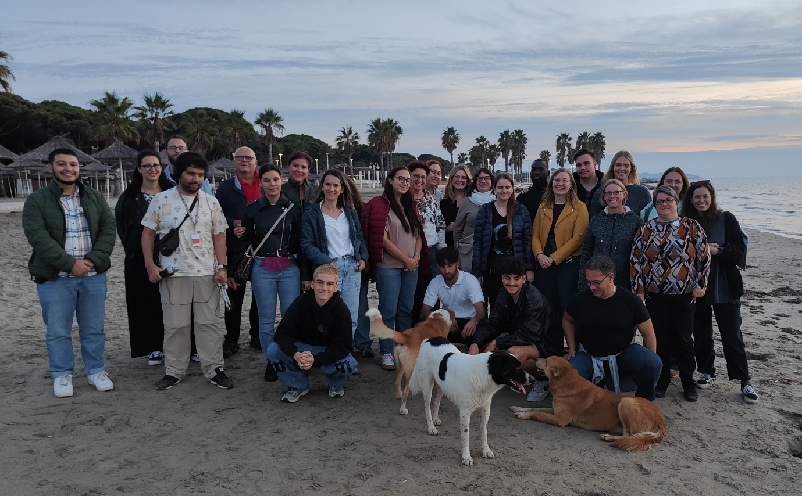
- In May 2025, we hosted a transnational study visit in Liège, where participants explored local practices in accessibility and inclusion in youth work. The week included visits to schools, youth centres, and associations, workshops on non-formal education and inclusion strategies, and opportunities for intercultural exchange.
- From 10 to 16 October 2025, participants met in Durrës and Golem, Albania, for the international training course, combining practical exercises on inclusive youth work with intercultural activities and reflection time along the coast.
- After each activity, an episode of the project podcast was recorded, giving participants a platform to share reflections, experiences, and insights, and allowing the wider community to hear authentic stories from the study visit and training course.

VIPPSTAR
In 2025, VIEWS International continued its work in the Horizon Europe project VIPPSTAR, leading the communication, dissemination, and exploitation efforts. VIPPSTAR supports children and adolescents with visual impairments in every aspect of their growth, recognising that their needs go far beyond vision. Using digital tools and AI, the project offers personalised and continuous support that nurtures physical, cognitive, and social development, helping young people gain autonomy, resilience, and a stronger sense of inclusion.
During the year, our focus was on making the project accessible and engaging to a wide audience. We launched the project website, developed the visual identity, and defined the communication, dissemination, and exploitation plan, paying special attention to accessibility and to reaching different target groups, including the scientific community, youth workers, families, and young people with visual impairments.
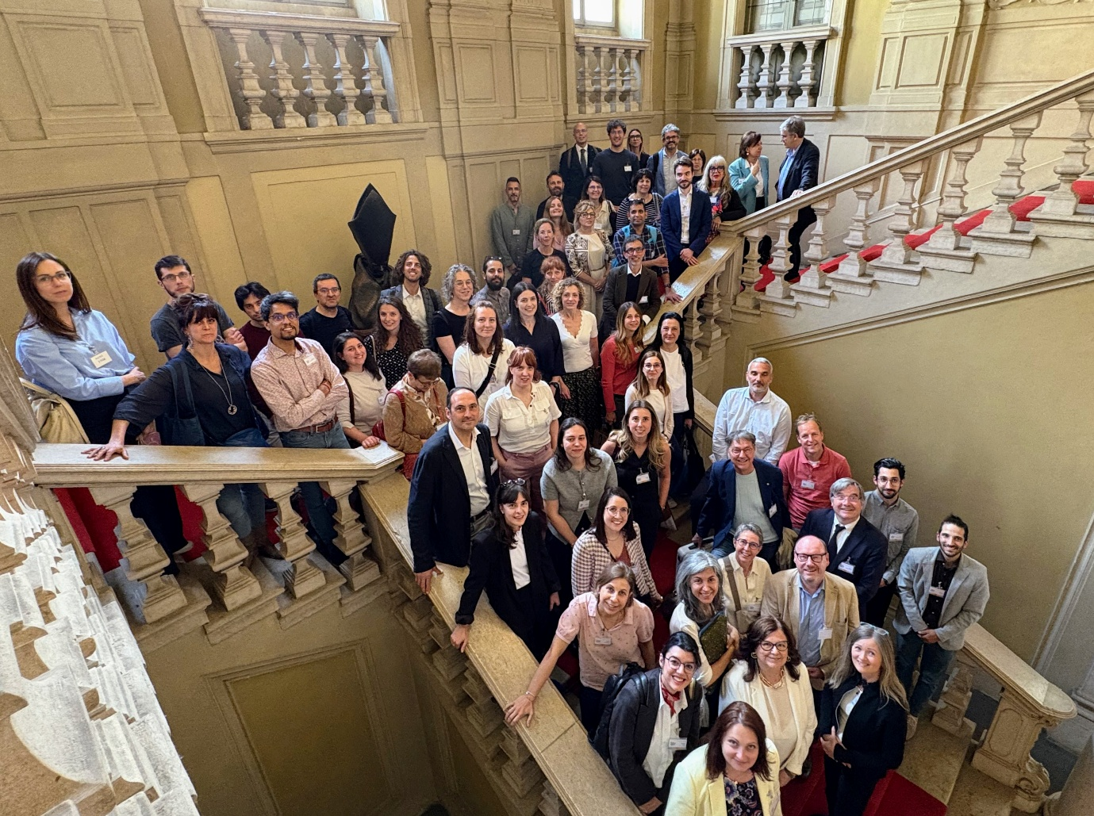
A highlight was the first in-person consortium meeting in Brescia, Italy, on 19–20 May, where partners from across Europe came together to review progress and plan the next phase. The meeting strengthened collaboration across research, clinical practice, and technology, advancing AI-based tools, serious games, and telehealth platforms, launching the transnational clinical data network VIPPSTAR-NET, and exploring how digital health solutions can empower families and young people.

Many new projects kicking off!

CYCLE-IN
CYCLE-IN is a European project launched in 2025 that promotes inclusion and well-being of visually impaired youth through tandem cycling and accessible outdoor activities. The project also supports youth workers in developing inclusive physical and outdoor education practices, encouraging participation, cooperation, and sustainable mobility.

Inclusive Horizons (InHo)
Inclusive Horizons (INHO) is a cooperation project aimed at improving digital accessibility and inclusion for physically and sensorially impaired youth. Through training activities, workshops, and practical resources, the project supports youth workers, young people, and their families, while addressing barriers to inclusion in education and employment.

W.I.N. Project
The Workspace Inclusion and Diversity (W.I.N.) project focuses on promoting inclusive and accessible workplaces. By applying Universal Design principles, the project supports organisations and professionals in addressing discrimination and improving the inclusion of persons with disabilities in the private sector.

VISTA
VISTA is a strategic partnership that started in 2025 and focuses on improving the accessibility of vocational education and training for visually impaired learners. The project works on inclusive teaching approaches, digital tools, and cooperation between training providers and employers. VIEWS International contributes to the project with a focus on accessibility, inclusion, and dissemination.

Language Tandems
Throughout the year, from the beginning of 2021, VIEWS International and its members organise accessible language tandems, gathering participants from anywhere in Europe in weekly or bimonthly online meetings to practice their language speaking skills in Spanish, French, Italian, German, English and Russian. The meeting are led by a team of volunteers who are native speakers and support the participants with tips and new vocabulary.

Awareness-raising Activities
Awareness-raising on persons with visual impairments and adapted international mobility programmes is another core activity of VIEWS International. These activities are crucial to inform the local community about the opportunities offered by the ESC and Erasmus+ programmes, and to create a general understanding of the issues faced by persons with visual impairments and the specific adaptations to put in place to favour their inclusion in society, education and on the workplace.

The Celebration of the Sainte Marguerite Neighbourhood
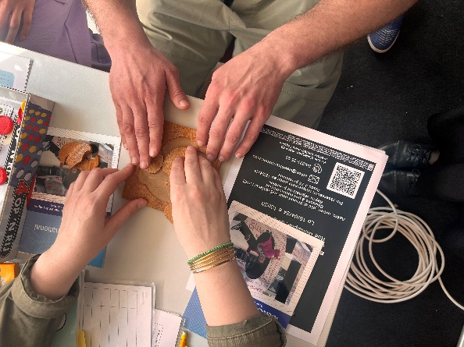
On 5 July we participated in the Fete du Quartier Sainte-Marguerite, an open and public event that allows us to be directly in touch with the local community and have a larger-scale impact with our advocacy. Through interactive activities and open conversations, and thanks to the invaluable contribution and participation of our ESC volunteers Kinga and Patricia, we spread awareness on the inclusion of persons with visual impairments and the importance of adaptive ESC/Erasmus+ programmes to make international mobility inclusive and accessible to persons with disabilities, and promoted our work to around 300 people.

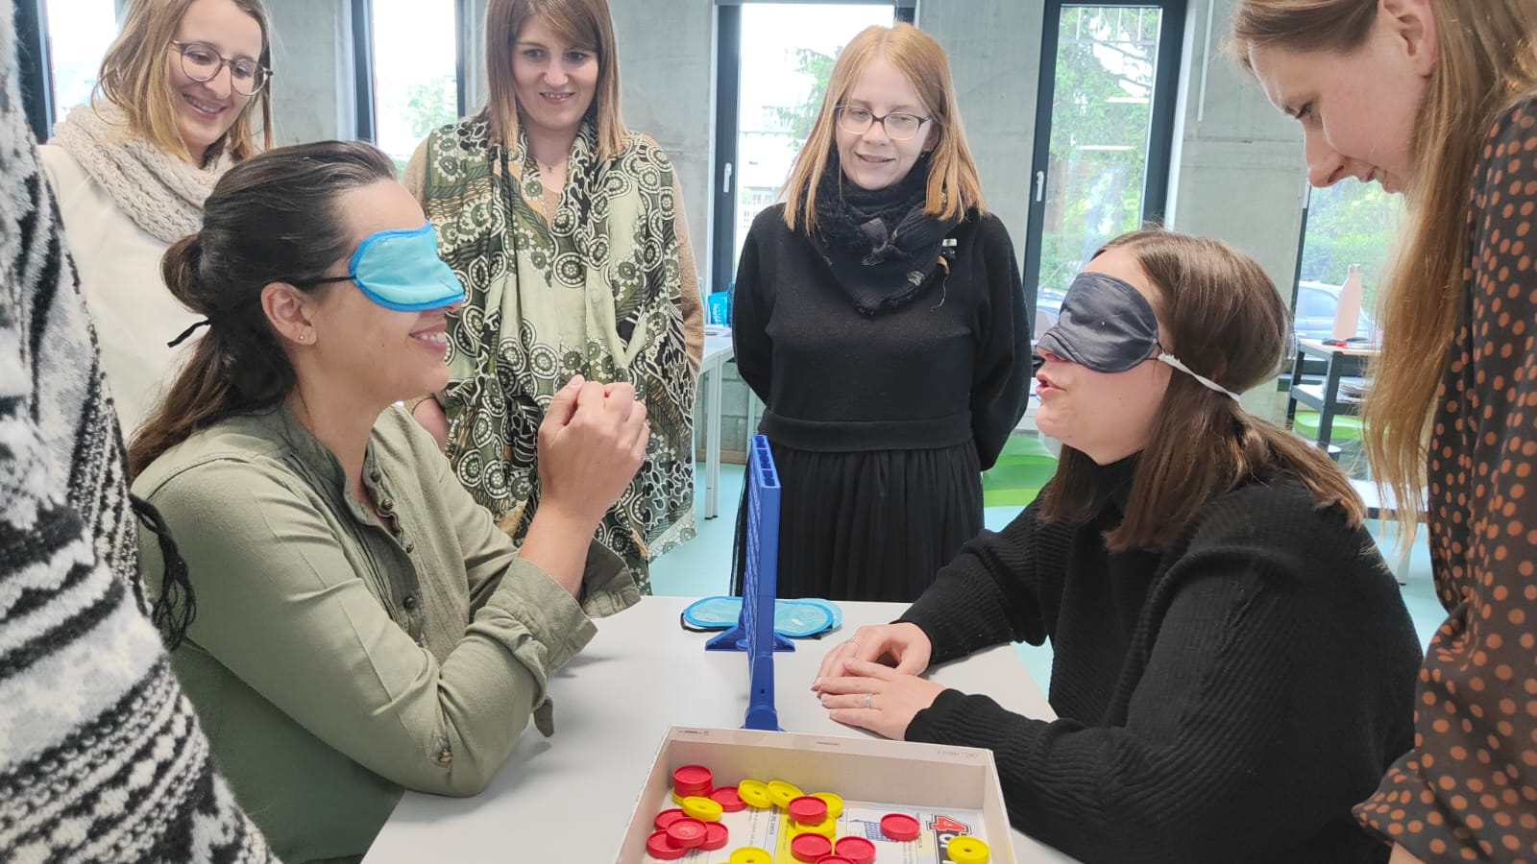
The workshop at the CPSE (Centre de Promotion Sociale Liège)
On 22 March, together with our intern Selma and our ESC volunteer Youssef, we held a workshop on innovative social work practices in the Centre for Continuous Education in Liège, where we met with students to introduce the purpose of VIEWS International and share information on the training and personal and professional development opportunities offered by the Erasmus+ Programme.

Cluj-Napoca city days
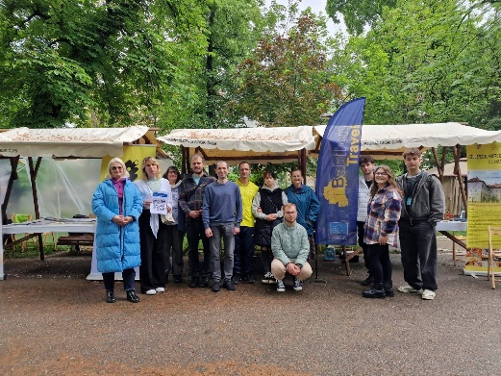
In May 2025, VIEWS International took part in the Cluj-Napoca City Days, a large public event organised in Central Park in Cluj-Napoca, Romania. The event provided an opportunity to engage directly with the local community and raise awareness about visual impairment, accessibility, and inclusive participation in public life.
Through interactive exchanges and informal conversations at the shared stand, visitors were invited to reflect on accessibility barriers and the importance of inclusive approaches in education, youth work, and community activities. Participation in the City Days allowed VIEWS International to reach a broad and diverse audience and contribute to greater public understanding of inclusion and accessibility.

External Representation
In 2025 we also participated in:

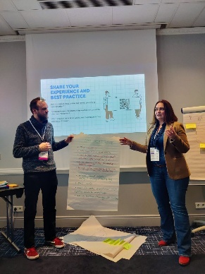
SNAC Conference
In early February, the event brought together around 150 participants from across Europe, including National Agencies, SALTO Resource Centres and organisations active in the European Solidarity Corps. It offered a valuable opportunity to exchange perspectives on the impact and future of youth volunteering, with a shared focus on inclusion, sustainability and meaningful engagement of youth.

MeetUP Mentoring Under Construction
On 25 February 2025, VIEWS International joined the online MeetUP Mentoring Under Construction Hidden Exclusion in Volunteering as a speaker, alongside other European actors. The session opened an honest discussion on unintentional barriers within the European Solidarity Corps, particularly for volunteers with visual impairments, and highlighted how accessibility, awareness and open communication play a key role in creating supportive and inclusive volunteering experiences.

XIX International Tool Fair
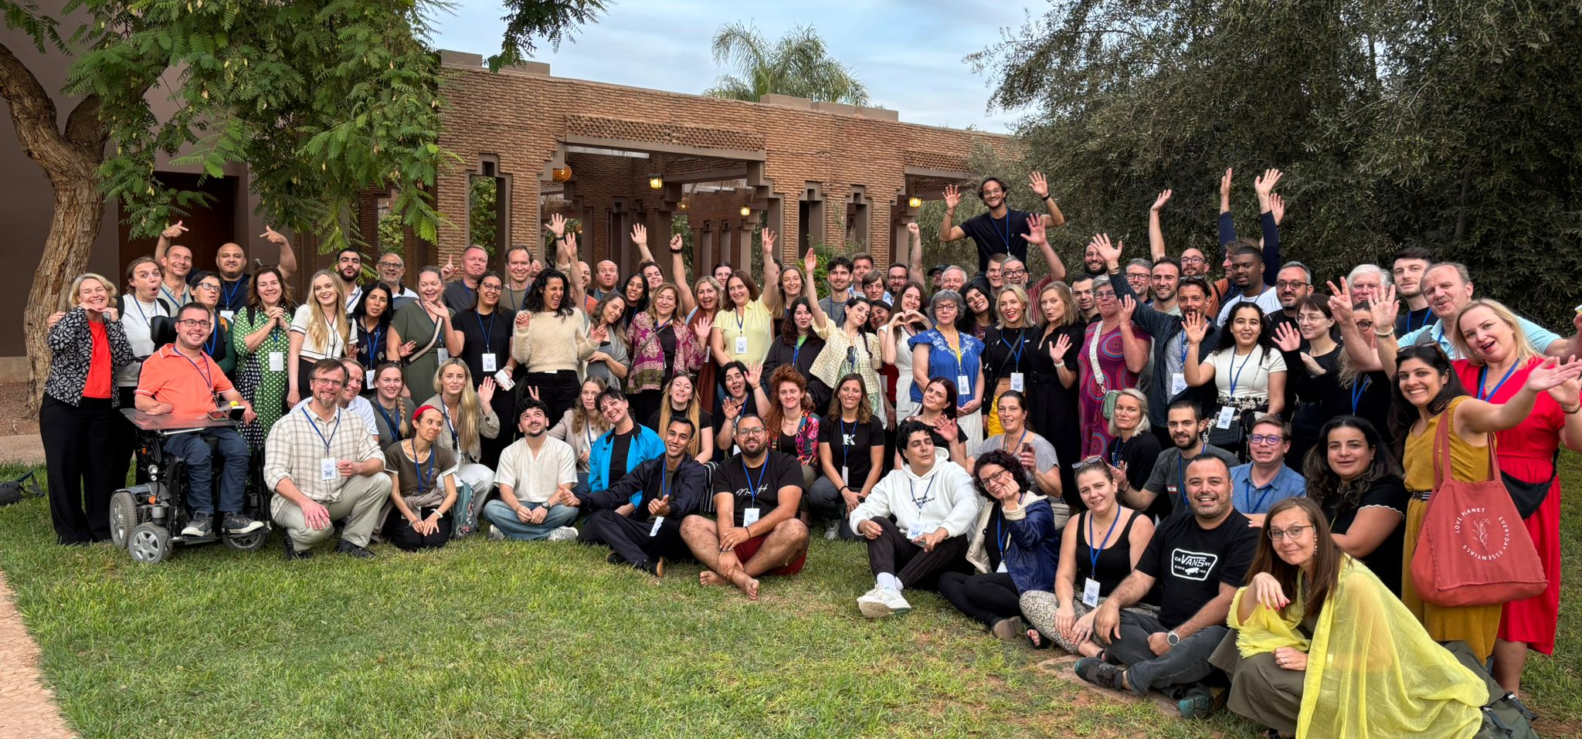
From 3 to 7 November 2025, VIEWS International took part in the nineteenth edition of the International Tool Fair in Marrakech, together with youth workers, educators and practitioners from 33 countries.
Under the theme Play Fair Sport as a Tool for Social Impact, the event created an open and practical space to explore how sport can support inclusion, wellbeing and community building through participatory learning methods and shared practice.

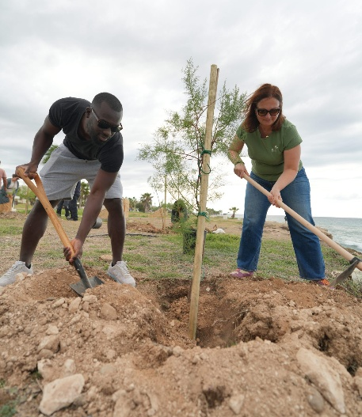
Digital Leaders for a Sustainable Planet

From 23 to 25 November 2025, representatives of VIEWS International and Loryhan asbl participated in the Digital Leaders for a Sustainable Planet professional development activity in Paphos, Cyprus. The Erasmus plus accredited programme combined digital tools and environmental awareness, allowing participants to strengthen their skills in communication and campaign design while reflecting on how youth work can support more sustainable practices at the local level.

European Days of Persons with Disabilities
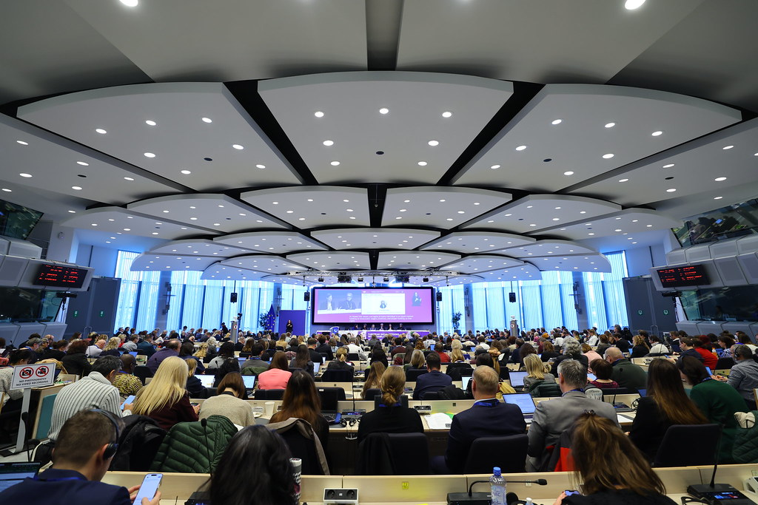
An event gathering experts and disability advocates in Brussels, Belgium to share concerns and expectations and to open the dialogue with public authorities and relevant stakeholders. This year, on 4 December, the event offered meaningful moments of reflection on independent living, mobility, political participation, employment and representation, within the framework of the EU Strategy for the Rights of Persons with Disabilities 2021 to 2030, reinforcing the importance of turning shared commitments into concrete action at the European level.

Document credits
This document was prepared by Giulia D’Agnolo
Assisted and supervised by Anca David
Revised and approved by the Board of Administrators of VIEWS International
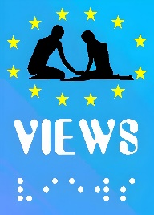
Visually Impaired Education and Work Support
Quai Van Beneden 19/1
4020 Liège , Belgium.
www.viewsinternational.eu
office@viewsinternational.eu
This publication has received financial support from the European Union. The information contained in this publication does not necessarily reflect the official position of the European Commission.

Funded by the European Union. Views and opinions expressed are however those of the author(s) only and do not necessarily reflect those of the European Union or EACEA. Neither the European Union nor the granting authority can be held responsible for them.”

