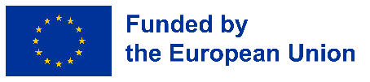
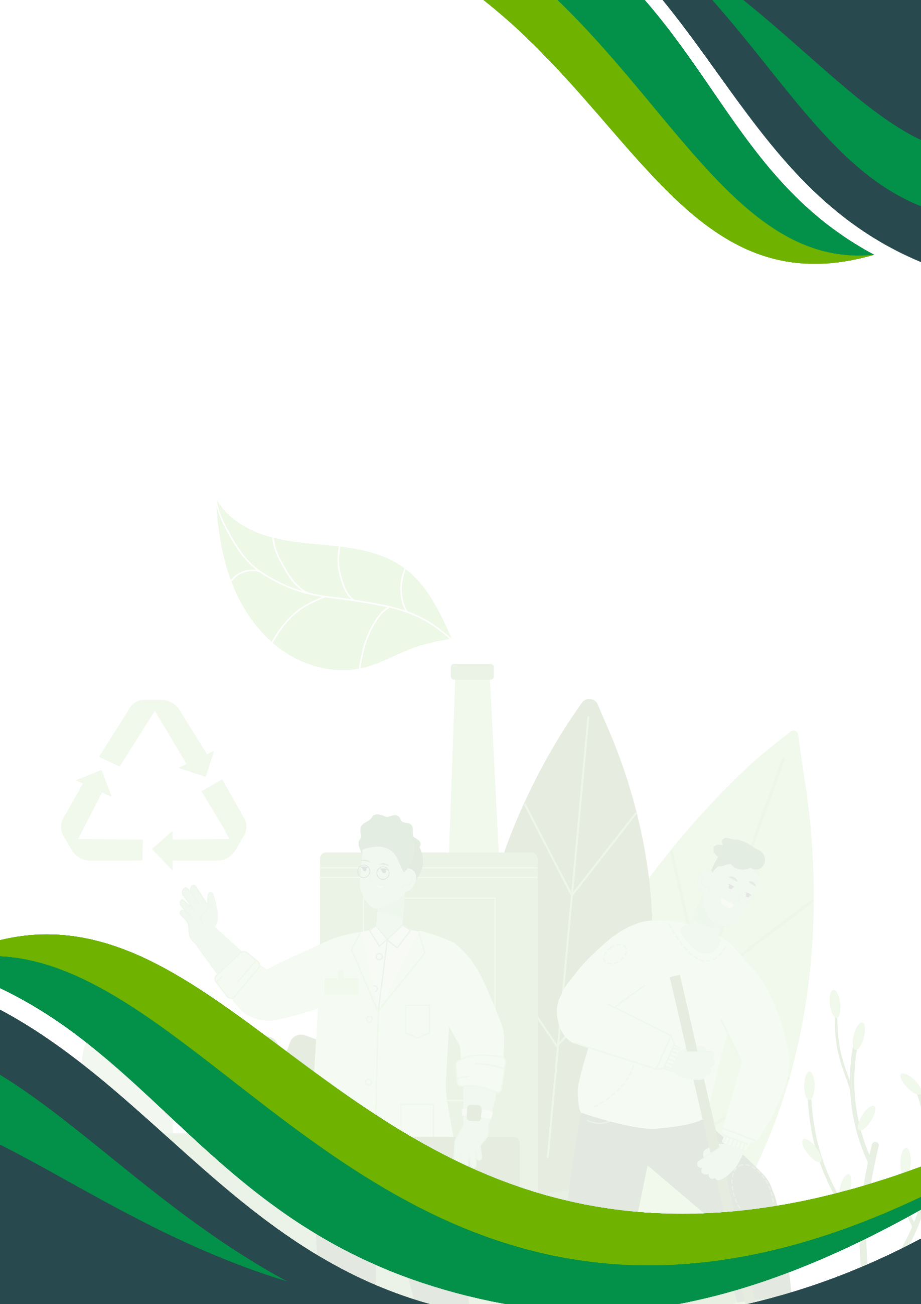

Project n. 2024-1-BE04-KA153-YOU-000240121

Inclusion for All

Tools and Insights to Mainstream Inclusion and Sustainability in Youth Work

Published in 2025
by the “Inclusion for All in Youth Work” project partnership:
VIEWS International AISBL
Loryhan ASBL
“Nyílj meg!” Foundation
Art House Educational and Cultural NGO
Asociatia Pentru Tineret Sakura
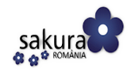

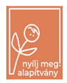
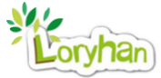


This publication has been produced with the support of the Erasmus+ Programme of the European Union. The contents of this publication are the sole responsibility of the “Inclusion for All in Youth Work” project partners and do not necessarily reflect the official views of the Bureau International Jeunesse and the European Commission.

Table of Contents
Introduction 3
The Inclusion for All project 3
The partnership 3
The core activities 4
3. The Inclusion for All Guidelines 6
The case for guidelines to mainstream inclusion and sustainability in youth work 6
What you will find in these guidelines 7
4. Study Visit in Romania: From Observation to Transformation 9
A roadmap for inclusive and sustainable youth work 9
1. Start With Awareness 9
2. Design for Everyone 10
3. Support Autonomy and Empowerment 10
4. Tackle Hidden Barriers 11
5. Collaborate for Inclusion Across Sectors 11
6. Use Ecology as a Tool for Empowerment 12
7. Reflect, Document, Replicate 12
Conclusion 13
5. Training Course in Belgium: From Theory to Application 14
Embedding accessibility, inclusion, and sustainability into youth work 14
1. Integrate Inclusion Intentionally 14
2. Embed Sustainability in Daily Activities 15
3. Clarify Roles and Share Responsibilities 15
4. Facilitate With Flexibility 16
5. Promote Replication and Scale 16
Conclusions 17
6. Recommendations for Accessible Activities within the Erasmus+ and European Solidarity Corps Programmes 18
A. Logistics and Practical Arrangements 18
B. Activity Design and Implementation 18
C. Clarifying Roles and Responsibilities 19
D. Accessible Tools and Assistive Methods 19
Final remarks 20

Introduction
Across Europe, youth work plays an essential role in helping young people develop skills, find their voice, and become active citizens. However, for many young people with disabilities or from disadvantaged backgrounds, access to these opportunities remains unequal. Structural barriers, lack of tailored support, and limited awareness often exclude them from participating fully in non-formal education and international mobility programmes. The Inclusion for All in Youth Work (I4ALL) project was created to address these gaps and promote a more inclusive and environmentally conscious youth sector.

The Inclusion for All project
I4ALL is a European cooperation project under the Erasmus+ programme (Key Action 153 - Mobility of Youth Workers), running from June 2024 to May 2025. It is coordinated by VIEWS International (Belgium) and implemented in partnership with asbl Loryhan (Belgium), Asociatia pentru Tineret Sakura (Romania), “Nyílj meg!” Autizmussal Élőkért Alapítvány (Hungary), and Art House NGO (Armenia). Each organisation brings its own experience in working with young people with fewer opportunities, whether they are visually impaired, with intellectual disabilities, neurodivergent, economically or geographically disadvantaged, or socially isolated.
The idea behind I4ALL emerged from a shared recognition among these partners: while many youth organisations are motivated to become more inclusive and sustainable, they often lack the tools, networks, and knowledge to do so effectively. The project’s central ambition is to empower youth workers to confidently design and deliver international projects that are accessible, participatory, and environmentally aware.
The focus of the project is not only on acquiring new skills and methods, but also on shifting mindsets. Inclusion is not treated as a checklist but as a guiding principle. Environmental awareness is not a side topic but an essential part of youth work in today’s context. I4ALL encourages youth workers to think critically about their own practices, to learn from others, and to build projects that reflect the realities and needs of diverse communities.
The partnership also aims to build long-term capacity within organisations. By involving both experienced and newer youth workers, as well as small grassroots organisations, the project fosters a community of practice across borders and generations. The previous collaborations among the partners, including inclusive youth exchanges, laid the groundwork for this shared journey. I4ALL strengthens these bonds and extends the network of youth professionals committed to change.

The partnership
VIEWS International (Belgium)
Founded in 2008 as an evolution of the earlier VIEWS NGO, Views International promotes inclusion, independence, and mobility for young people with visual impairments across Europe and beyond. It supports visually impaired youth through youth exchanges, volunteering, training, and professional development programmes. Rooted in European values of solidarity and accessibility, the organisation fosters active participation rather than passive assistance and is known for its inclusive, user-centred methodologies.
SAKURA Youth Organisation (Romania)
Established in 1990 in Bucharest, SAKURA is a youth-driven NGO advocating for freedom of thought, expression, and human rights. With strong roots in civic education and democratic engagement, the association develops programmes for disadvantaged young people and offers consultancy for implementing European projects. It has recently focused more on inclusive youth work, particularly in legal, educational, and social fields.
Loryhan (Belgium)
Loryhan is a youth and community centre in the Belgian Ardennes that provides space for inclusive gatherings, educational activities, and international projects. With a strong commitment to solidarity and rural youth engagement, it supports young people—especially those facing financial or social exclusion—to participate in local and European-level initiatives.
“Nyílj meg!” Foundation (Hungary)
This Hungarian foundation was created by parents of disabled children to support their transition to adult life. It offers employment, life skills, and community-based leisure for young adults with autism, Down syndrome, or intellectual disabilities. Its inclusive farm project combines sustainability and work experience while creating peer and family support networks.
Art House Educational and Cultural NGO (Armenia)
Registered in 2020, Art House supports youth empowerment and inclusion through art, education, and non-formal learning. It addresses social exclusion and stigma experienced by disabled youth, and provides therapeutic services, employment pathways, and skill development. The organisation fosters intercultural dialogue and civic engagement through local and international activities, cultural clubs, and volunteering initiatives.

The core activities
To achieve this, I4ALL combines learning-by-doing, international exchange, and collaborative reflection through two core transnational activities:
- The first is a Study Visit in Romania (November 2024), during which participants explore inclusive education and social services, engage in field visits, and reflect on national approaches to disability and inclusion;
- The second is a Training Course in Belgium (March 2025), where participants gain in-depth knowledge on how to adapt Erasmus+ and European Solidarity Corps (ESC) projects to various inclusion needs, and how to integrate green practices into project planning and delivery.
In total, the project brings together fifty participants, including staff, volunteers, and youth leaders, many of whom come from underrepresented backgrounds themselves.
At the heart of the project lies a commitment to tangible and lasting results. One of its key outputs is this set of guidelines, a practical and accessible resource for youth workers across Europe and beyond.

The Inclusion for All Guidelines

The case for guidelines to mainstream inclusion and sustainability in youth work
The “Inclusion for All” project is grounded in a shared recognition among European youth organisations that young people with disabilities and from disadvantaged backgrounds continue to face significant barriers to participation, personal growth, and social inclusion. These barriers are not only physical, but also institutional, cultural, and economic—and they vary considerably across national and regional contexts.
Across Europe, youth with fewer opportunities, including those with disabilities, from socio-economically marginalised backgrounds, rural areas, or minority communities, often encounter persistent obstacles in both formal and non-formal education. These difficulties stem from inaccessible environments, fragmented support systems, and limited awareness of their specific needs. For young people with disabilities especially, meaningful participation in everyday youth activities or mobility projects often requires additional planning, adaptation, and informed facilitation, which are conditions not consistently present in mainstream youth work.
Despite increasing awareness of the importance of inclusion, many youth workers report feeling underprepared to support these young people effectively. Common challenges include insufficient training, a lack of specialised resources, and limited experience in adapting methods to meet diverse needs. Smaller or newer organisations may find it particularly difficult to design programmes that are simultaneously inclusive, accessible, and relevant, which may lead in some cases to the unintentional exclusion of the very participants they aim to include.
These challenges are regularly observed by organisations working on the ground. They describe how difficult it can be for young people with disabilities to access activities that are otherwise routine for their peers. Too often, inclusion remains an ambition rather than a practice, not due to a lack of will, but due to the absence of practical tools, examples, and shared expertise.
The situation varies across countries:
In Romania, particularly in rural or peri-urban areas such as Ilfov, young people face poor transport infrastructure, inaccessible public buildings, and limited inclusion in mainstream education. For youth with disabilities, these barriers are compounded by social stigma and insufficient public support. In many cases, it is NGOs that provide the only real pathways to participation and support.
In Belgium, particularly in more isolated rural regions like the Ardennes, young people face geographic remoteness, limited access to inclusive services, and uneven implementation of inclusion policies. Youth workers in these settings are often overburdened and under-resourced, with limited opportunities for training on inclusive practice. Many young people with fewer opportunities face an increased risk of social isolation and professional marginalisation.
In Hungary, youth work is hindered by underfunded services and low public investment. Young people with intellectual or developmental disabilities encounter significant challenges in education and employment, and inclusion is often constrained by a lack of structural support. Schools are frequently ill-equipped to accommodate diverse learners, and the transition into adult life remains a major challenge.
In Armenia, youth work is still developing. A national youth policy framework is only now taking shape, and youth work as a profession remains largely informal. Youth with disabilities face systemic inequalities, including physical inaccessibility, social exclusion, and widespread discrimination. In this context, youth workers often operate without stable funding or professional support, and lack the training required to implement inclusive approaches.
Against this backdrop, the “Inclusion for All” Guidelines offer practical, context-aware responses aimed at building capacity among youth workers and organisations. They draw on the experiences of partners working directly with marginalised young people and are intended to support a shift from aspiration to action. By providing tools, strategies, and real-life examples, the guidelines contribute to making youth work more inclusive, participatory, and responsive to the requirements of all young people.

What you will find in these guidelines
These guidelines are the main intellectual output of I4ALL. They were developed during the project activities as a way to consolidate learning, share good practices, and inspire other youth professionals to take meaningful steps toward inclusion and sustainability in their own work.
The guidelines aim to:
- Offer clear and adaptable strategies to make Erasmus+ and ESC projects more inclusive for young people with disabilities and from vulnerable backgrounds
- Provide examples of best practices observed during the study visit and training course
- Encourage youth workers to embed green practices into the planning and delivery of non-formal education
- Support organisations - especially those new to EU programmes - in navigating accessibility, project design, and partnership building
- Present reflections and case studies from participants across different countries and contexts
This toolkit is intended for youth workers, youth leaders, project coordinators, trainers, educators, and grassroots organisations. Whether you are preparing your first project proposal or looking to deepen your understanding of inclusive practice, the following pages will guide you through tested ideas, reflections, and useful recommendations developed by peers working in the field.
By sharing what we learned through “Inclusion for All”, we hope to help others take the next step toward a youth sector where inclusion is a standard, not an exception, and where environmental and social responsibility go hand in hand.

Study Visit in Romania: From Observation to Transformation

A roadmap for inclusive and sustainable youth work
The Study Visit in Romania, hosted by “Asociatia pentru Tineret Sakura” in November 2024, marked the first major activity of the I4ALL project. It brought together youth workers, youth leaders (like ESC volunteers or local volunteers), and educators from Belgium, Hungary, Armenia, and Romania to observe, learn, and exchange best practices related to the inclusion of young people with disabilities and those from disadvantaged backgrounds. At the same time, it offered opportunities to reflect on how environmental sustainability can be embedded into everyday youth work practices.
The Study Visit was conceived as an immersive, participatory experience. Through school visits, collaborative workshops, contextual reflections, and direct engagement with the local community, participants gained a grounded understanding of what inclusion can look like in practice. From these activities and the reflections that followed, they were able to draw new tools and ideas, and renewed motivation.
This section presents the main learning outcomes of the Study Visit through a combination of narrative reflections, real-life examples, and concrete action points that youth organisations can apply in their own work.

1. Start With Awareness
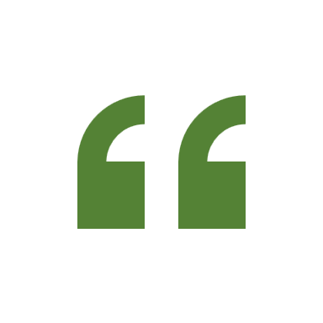
A key takeaway from the Study Visit was that inclusion does not begin with physical adaptations or technical tools, but with a shift in perspective. Youth workers need to examine their own assumptions, attitudes, and practices in order to meaningfully support diverse groups of young people.
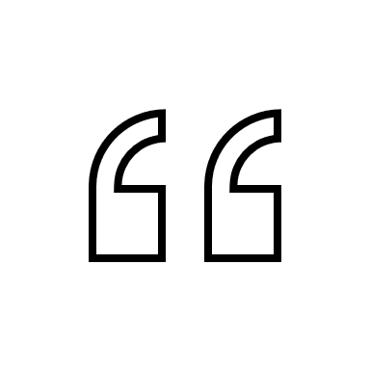
“Inclusion means making everybody welcome and part of the group equally.”
– Camelia, student
In action: Throughout the visit, participants heard from local students such as Camelia and Iulia, who shared how their understanding of diversity had evolved through direct contact with ESC volunteers and international youth workers. They began to recognise that exclusion often stems not only from physical or financial barriers, but from unspoken social norms and habits.
Action Points:
- Begin each new project by facilitating a group discussion around the meaning of inclusion. Encourage participants to share personal experiences and co-develop a common definition.
- Integrate simple yet consistent reflective practices into everyday activities, such as group check-ins, silent walks, or informal discussions on access and participation.
- Integrate simple yet consistent reflective practices into everyday activities, such as group check-ins, silent walks, or informal discussions on access and participation.

2. Design for Everyone
Many youth projects address inclusion reactively rather than proactively. The Study Visit demonstrated the importance of planning for diversity from the outset, rather than adapting only once challenges arise.
C
“Now we double-check if someone has a need before starting an activity. We want to make sure everyone is part of it.”
– Georgiana, student
In action: Volunteers and students collaborated to ensure that learning activities accommodated a variety of needs. For example, tactile tools, visual aids, and alternative communication formats were introduced to help all participants engage equally. Volunteers adjusted facilitation on the spot, based on group dynamics and individual needs.
Action Points:
- Include a comprehensive accessibility review in your planning process. Consider physical, cognitive, sensory, and emotional access.
- Provide all materials in multiple formats—spoken, visual, written, and digital—to meet different preferences and requirements.
- Appoint an “accessibility lead” or designated inclusion focal point to oversee implementation during activities.

3. Support Autonomy and Empowerment
An important realisation during the visit was that youth workers can sometimes become overly cautious in their efforts to support young people with disabilities. In doing so, they risk limiting opportunities for independence and self-expression.
“Support is there for a reason. But it does not mean treating someone like a child.”
– Sakura youth worker

In action: Participants such as Carmen, a visually impaired former ESC volunteer at VIEWS International and accessibility expert, provided a powerful example of autonomy in action. With access to the right tools, clear instructions, and mutual trust, she was able to navigate complex environments independently. Her participation served as a reminder that inclusion must also involve confidence in young people’s capacity.
Action Points:
- Engage directly with individuals to understand their preferred methods of support. Avoid making assumptions.
- Introduce assistive technology and practical tools that promote independent engagement.
- Foster peer-to-peer support in a way that builds shared responsibility and respect.

4. Tackle Hidden Barriers
While physical access is essential, many barriers are less visible and often overlooked. These include financial constraints, linguistic challenges, neurodivergence, and mental health conditions. During the Study Visit, participants explored how to recognise and respond to such challenges effectively.
“Some students could not afford food on our trip, so I planned food packs instead of going to restaurants.”
– Tiago, former ESC volunteer and Youth leader
In action: When planning a field trip, Tiago noticed that some students were quietly opting out due to the cost of eating out. Rather than allowing this to limit their participation, he introduced an alternative—home-prepared meals for the entire group. This proactive choice removed the barrier and reinforced equity.
Action Points:
- Identify potential socioeconomic barriers in advance. Budget to cover items such as meals, transport, and materials where needed.
- Collect anonymous feedback or conduct pre-activity surveys to anticipate additional needs.
- Provide clear, simple, and multilingual communication. Incorporate translation tools, image-based or audio resources, and inclusive facilitation styles.

5. Collaborate for Inclusion Across Sectors
One of the most impactful aspects of the visit was the emphasis on cross-sector collaboration. Inclusion became more effective and sustainable when schools, local authorities, NGOs, and volunteers worked together towards a common goal.
“We want to bring that spirit back to the Ardennes.”
– Loryhan staff member
In action: In several of the schools visited, ESC volunteers were integrated co-facilitators of co-curricular activities. Their involvement contributed to a broader culture of openness, support, and ecological awareness. Teachers and school leaders testified to the long-term value of these partnerships.
Action Points:
- Develop structured partnerships with schools, youth services, or cultural institutions. Propose collaborative projects that reinforce inclusion and sustainability.
- Involve ESC or local volunteers as regular contributors to educational and extracurricular programming.
- Communicate the outcomes of such collaborations publicly to raise awareness and build trust with local stakeholders.

6. Use Ecology as a Tool for Empowerment
Tiago’s activity during the Study Visit illustrated how sensory, hands-on experiences can make environmental education both inclusive and impactful. By using simple materials and real-world metaphors, he enabled all students—regardless of background or ability—to engage with complex ecological systems in a way that was both accessible and meaningful.
“We are the ones who can make an impact in the long term, so we need to start now.”
– Camelia, student
In action: Tiago guided a workshop in which students built small ecosystems using recycled bottles. As they introduced pollutants, they observed how their actions directly affected the plants inside. This simple yet powerful visual and tactile exercise helped young people understand cause and effect, interconnectedness, and responsibility within environmental systems. It also created a space where students with different learning styles could participate equally and contribute insights during reflection.
Action Points:
- Integrate locally relevant ecological activities into your programmes. Focus on learning-by-doing, using accessible formats.
- Explore environmental justice as a theme. Discuss how ecological issues disproportionately affect marginalised communities.
- Adopt green practices throughout your project management process, from procurement to waste reduction.

7. Reflect, Document, Replicate
One of the final lessons of the Study Visit was the importance of reflection and knowledge-sharing. Inclusive and sustainable youth work does not happen by chance—it emerges from consistent reflection, intentional documentation, and active peer exchange. Throughout the week, several plenary reflection sessions were built into the programme. These moments gave space for participants to contribute ideas, raise challenges, and collect recommendations from diverse organisational and national perspectives. The practice of learning from one another became just as valuable as the field visits themselves.
C“We have already started implementing lessons at home and shared them with our institute.”
– Art House representative
In action: Following the Study Visit, each organisation committed to integrating new tools and approaches into their regular practice. Some revised their accessibility checklists and adjusted internal planning frameworks. Others began strengthening cooperation with local institutions or piloting new inclusive initiatives. The learning extended beyond individual awareness and became embedded in organisational culture and strategy.
Action Points:
- Schedule regular reflection moments within your projects. Use different formats such as audio diaries, drawings, group discussions, or written evaluations.
- Develop internal resources based on your learning. This may include case studies, tip sheets, or inclusive project templates.
- Share your results with peers, partners, and the broader youth work community through events, networks, or online platforms.

Conclusion
The Study Visit in Romania confirmed that inclusion is not a one-time task but a mindset, a process, and a practice. When combined with environmental awareness, it creates a framework for youth work that is both relevant and transformative. The examples and actions described here are not specific to Romania—they can be adapted and implemented in any local context where youth workers are committed to equity, participation, and sustainability.

Training Course in Belgium: From Theory to Application

Embedding accessibility, inclusion, and sustainability into youth work
The Training Course in Botassart, Belgium, held in March 2025, represented the second major transnational activity of the I4ALL project. Organised by VIEWS International and Loryhan, the course gathered youth workers, facilitators, youth leaders like former ESC volunteers, and project staff from Belgium, Romania, Hungary, and Armenia. Together, they examined how inclusive and environmentally conscious practices can be embedded directly into European Solidarity Corps and Erasmus+ projects.
Through a mix of practical sessions, personal testimonies, immersive exercises, and facilitated co-creation, the course aimed not only to raise awareness but to equip participants with a set of tools, examples, and skills they could implement in their home contexts.
This section presents a synthesis of the Training Course’s outcomes—blending narrative context with concrete recommendations and transferable practices. It is designed to serve as a roadmap for other youth organisations aiming to integrate inclusion and sustainability into their international projects.

1. Integrate Inclusion Intentionally
Across the sessions, one message became clear: inclusion does not occur by accident. It must be present in every aspect of the project lifecycle—from planning and logistics to group dynamics and evaluation.
“Inclusion starts with the invitation—who we ask to the table defines what the table becomes.”
— Participant from Armenia
In action: In workshops and group exercises, participants explored practical ways to incorporate accessibility into application forms, communication, and activity planning. The idea was not to “fix” problems later but to prevent exclusion by anticipating a range of needs. For example, Hungarian participants described how they had already begun redesigning their project templates to include accessibility and environmental awareness as standard components.
Action Points:
- Include accessibility and inclusion as core criteria when designing a project—not as add-ons.
- Adapt tools, spaces, and activities to a variety of access needs from the start. Use multiple formats (print, digital, verbal, tactile).
- Define specific inclusion objectives within your application form and evaluation framework.

2. Embed Sustainability in Daily Activities
The course underscored that sustainability in youth work must go beyond symbolic gestures. It must be visible, lived, and linked to daily practice. Participants were encouraged to explore how eco-consciousness could be introduced in inclusive ways, reaching not only environmentalists but all youth.
“Sustainability is not an abstract principle. It lives in the food you serve, the places you visit, and the energy your team uses.”
— Loryhan team member
In action: Attila, a youth worker from Hungary, described how a visit to a local water supply site transformed his perception of environmental education. This was echoed in the design of the course itself, which incorporated recycled materials, vegetarian meals, and community-based excursions. Several organisations, including Sakura and Art House, reported that they began planning eco-camps or sharing green practices with local partners as a result.
Action Points:
- Reduce the environmental footprint of your project by sourcing locally, printing minimally, and managing waste carefully.
- Choose venues with sustainability certifications or active ecological practices.
- Integrate environmental topics into programme content through workshops, challenges, or field visits.

3. Clarify Roles and Share Responsibilities
Another essential lesson from the Training Course was the importance of clearly defining the roles of each actor involved. Whether host, sending organisation, participant, or volunteer, each person contributes to creating an inclusive space.
“Once you have the right person checking the right thing, inclusion becomes natural.”
— Abraham, Loryhan facilitator
In action: Participants from Art House shared how they had begun assigning “inclusion focal points” in their team and involving country group leaders in creating inclusive icebreakers and energisers. They also stressed the need for inter-team communication prior to international activities, to ensure all access needs are well understood and planned for.
Action Points:
- Define roles and responsibilities related to accessibility at all stages of project preparation.
- Coordinate between sending and hosting organisations early to gather access requirements and co-develop individual support plans.
- Engage participants in co-creating group rules, support systems, and inclusive practices.

4. Facilitate With Flexibility
The training highlighted that inclusion is not only about logistics. It also involves facilitation methods that respond to diverse ways of learning, expressing, and engaging. Trainers were encouraged to use multimodal tools, accessible language, and adaptable formats.
“There were programmes where you did not need to speak: drawing, singing, moving. Those were my favourite.”
— Participant from Hungary
In action: From body movement therapy sessions to multilingual materials and non-verbal communication games, the training offered a diverse array of ways to engage. Anna and Silviu, co-facilitators and accessibility supervisers from VIEWS and Sakura, reinforced the importance of designing spaces where all contributions are valued, regardless of how they are communicated.
Action Points:
- Use a mix of facilitation techniques: visual, verbal, tactile, physical, and digital.
- Provide alternatives for participation such as sketching, mind mapping, or voice recording.
- Allow quiet time, emotional check-ins, and reflection to ensure psychological safety.

5. Promote Replication and Scale
Participants and organisations reported that the course had already begun to shape how they approach youth work at home. Several groups initiated new partnerships, revised their project models, and began sharing learnings with their broader networks.

“We included green and inclusion sections in our new project templates. This is now how we will approach everything.”
— Art House team
In action: Following the course, Art House and other partners began preparing new projects with integrated accessibility plans. Sakura initiated a new eco-camp with an inclusion dimension. Hungarian participants delivered reflection sessions in their home institutions to disseminate learnings.
Action Points:
- Use debriefing sessions to collect immediate feedback from participants and staff.
- Revise project documents and internal templates to embed inclusive and green practices.
- Share learnings with your ecosystem—schools, municipalities, national agencies, and civil society actors.

Conclusions
The Training Course in Belgium was not only an opportunity for learning, but a space for mutual transformation. Through collective reflection, lived experience, and structured exchange, it provided a model for what inclusive, accessible, and sustainable youth work can look like when it is designed with intention and care.
The practices, tools, and principles outlined above are not unique to this context—they are adaptable across regions, themes, and funding programmes. They invite youth workers and organisations across Europe to reimagine inclusion not as a challenge, but as a foundation for meaningful, equitable engagement.

Recommendations for Accessible Activities within the Erasmus+ and European Solidarity Corps Programmes
This section presents practical recommendations for making Erasmus+ and ESC projects more inclusive and accessible. It draws from observations and feedback gathered during the Study Visit and Training Course of the I4ALL project and is informed by the practices of partners such as Sakura, VIEWS International, Art House, YWFO, Loryhan, and their local collaborators. The recommendations are organised into four thematic areas to guide organisers and youth workers in building inclusive environments from the ground up.

Logistics and Practical Arrangements
Accessibility is not something to be added as an afterthought. Organisers should treat it as a core principle from the moment the project is conceived.
Recommendations:
- Choose venues with wheelchair access, ramps, wide doors, and clear signage.
- Ensure bathrooms and bedrooms are adapted or adjustable for different physical needs.
- Provide orientation sessions, including visual or tactile maps and a tour of the space.
- Use a detailed pre-project survey to collect dietary, mobility, sensory, and communication needs.
- Build enough flexibility into transport plans to include walking alternatives or vehicle access as needed. This proved helpful in Botassart when deciding which activities required walking or vans.
- Plan quiet spaces and designated rest zones accessible throughout the day.
Best Practice Example:
In Botassart, project staff tailored logistics based on participants’ profiles: those with visual impairments were offered tactile guides and verbal orientation, while participants with sensory sensitivity had access to quiet corners. Pre-arrival information included photos of the venue and sample menus.

Activity Design and Implementation
Inclusive activities accommodate different ways of learning, expressing, and engaging. Youth workers must be prepared to adapt both content and delivery methods.
Recommendations:
- Use multiple learning formats: verbal, written, visual, tactile, audio and performative.
- Include non-verbal expression methods such as drawing, body movement, gesture-based exercises, or audio reflections.
- Offer breaks and decompressing moments between intense sessions.
- Avoid long, text-heavy sessions. Instead, use games, diagrams, storyboards, and lived examples.
- Ensure group work is inclusive by assigning mixed teams and rotating facilitators.
- Offer alternative participation modes in all sessions (e.g. writing vs speaking vs acting out answers).
Best Practice Example:
During the training course, facilitators encouraged alternative ways of communicating—drawing, pantomime, or singing were not just accepted but embedded into the sessions. Participants with limited verbal English felt more involved and safer to contribute.

Clarifying Roles and Responsibilities
Creating accessible environments requires clearly defined roles for each stakeholder involved. All actors - hosts, partners, volunteers, and participants - have a role in creating inclusion.
Recommendations:
- Appoint an “Inclusion Coordinator” within the host team who manages needs, adaptations, and real-time problem-solving.
- Encourage sending organisations to prepare participants in advance and collect access requirements early.
- Empower participants to speak about their own needs and expectations without fear of judgment.
- Prepare staff and local volunteers for inclusive roles: assisting peers, helping during meals or workshops, supporting communication.
- Hold partner meetings prior to arrival to clarify responsibilities and co-design inclusive strategies.
Best Practice Example:
Abraham from Loryhan highlighted how assigning an inclusion focal point ensured that no issue was left unaddressed. Meanwhile, Art House stressed the importance of mixed group facilitation and team-building led by trained country leaders.

Accessible Tools and Assistive Methods
Tools should not overwhelm the process. Instead, they should respond directly to the expressed needs of participants, and be easy to adopt by any team member.
Recommendations:
- Provide materials in multiple formats (large print, Easy-to-Read, digital, Braille, audio).
- Use translation apps, live captioning, and basic sign language when appropriate.
- Integrate tactile and 3D tools (e.g. textured floor maps, object-based activities, 3D layouts).
- Apply colour contrast standards and legible fonts in presentations and documents.
- Develop guides for participants in plain language with icons or image support.
- Train facilitators in assistive technology use such as screen readers, voice typing, or live AI translators.
Best Practice Example:
One example from Sakura involved using AI tools to generate real-time summaries of group discussions in Hungarian and then having them translated to English via voice AI, a practice that allowed all participants to follow the dialogue comfortably.

Final remarks
The “Inclusion for All in Youth Work” project set out to explore how accessibility, inclusion, and environmental sustainability can move from aspiration to practice within the youth sector. Through the Study Visit in Romania and the Training Course in Belgium, youth workers, volunteers, and partner organisations worked together to test ideas, adapt tools, and create environments where all young people can participate fully and meaningfully.
These guidelines bring together what was learned in practice, what was refined through collaboration, and what was shared across national and cultural contexts. They are not fixed formulas, but practical foundations offering methods, examples, and questions to support more inclusive and environmentally aware approaches in youth work.
Inclusion and sustainability are not outcomes to be achieved once, but values that require ongoing attention, flexibility, and collective effort. As you explore and apply these guidelines in your own projects, we invite you to continue questioning, adapting, and sharing. The true legacy of this work lies in how many more young people are empowered to take part, lead, and thrive within spaces that genuinely welcome them.

