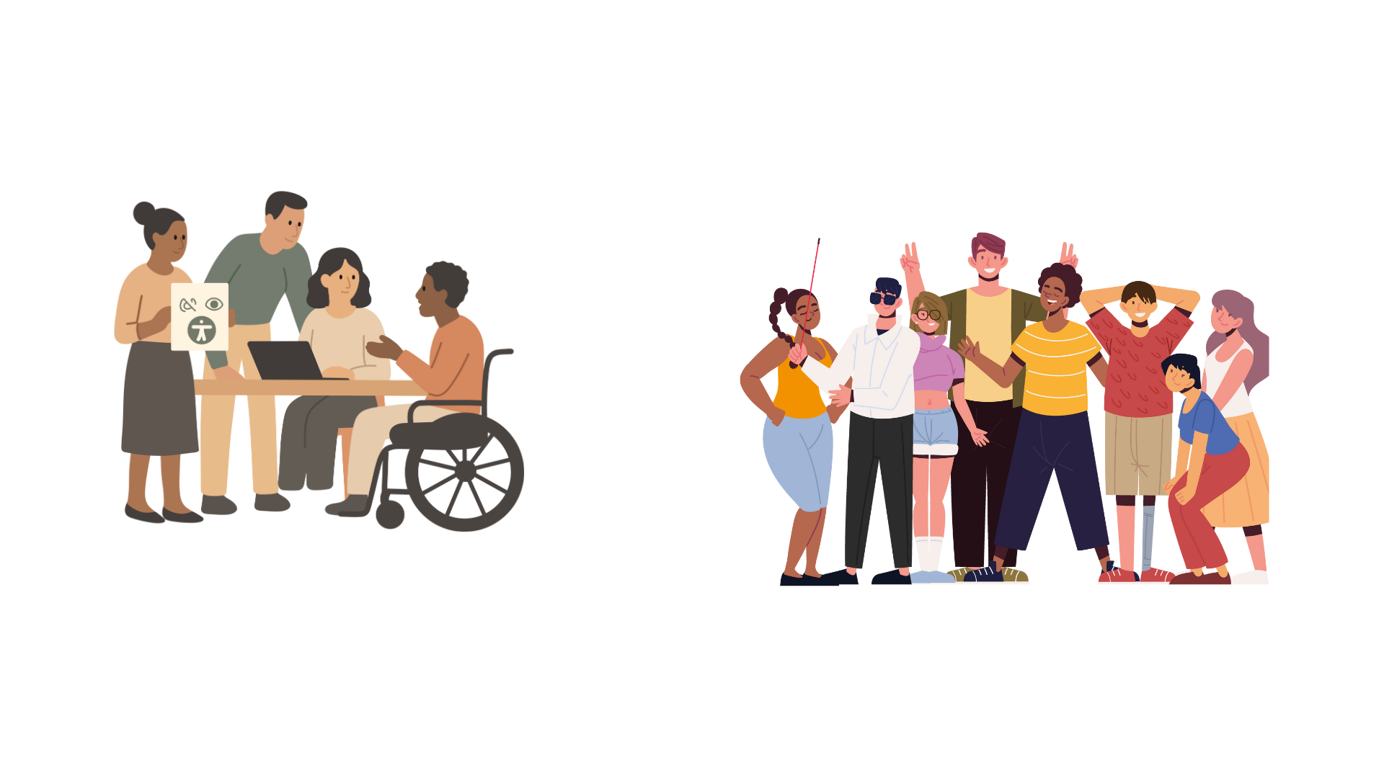
INCLUSION IN PRACTICE

Lessons from the ACT-YOU project



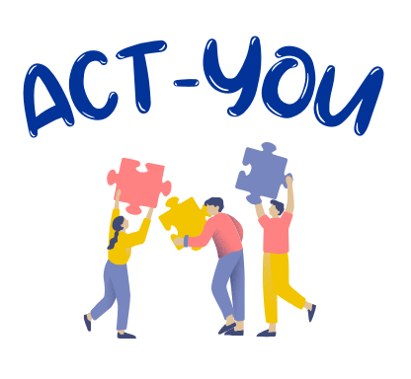

This publication was developed in the frame of the project “ACT-YOU: Promoting ACTive participation in professional development activities for YOUth workers, youth leaders, organisations and institutions involving young people with fewer opportunities.” (project No.: KA153-YOU-F252DB5C).
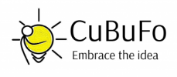
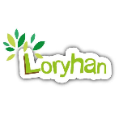
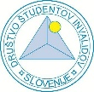

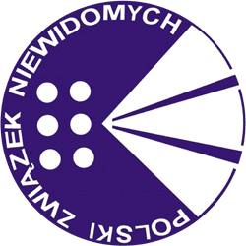
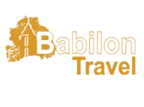
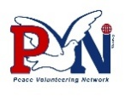
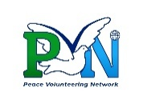

Participated in the development of this publication: VIEWS International, CuBu Foundation, Slovenian Association of Disabled Students (DŠIS), NGO Sakura, Polish Association of the Blind (PZN), Peace Volunteering Network (PVN), Peace Volunteering Network Norway, Loryhan asbl, Asociația Babilon Travel (ABT).



Funded by the European Union.
Views and opinions expressed are however those of the author(s) only and do not necessarily reflect those of the European Union or the National Agency. Neither the European Union nor the granting authority can be held responsible for them.
TABLE OF CONTENTS
INTRODUCTION 4
Our Partnership 4
The ACT-YOU Project 6
Why these recommendations 6
Transport and Venue Accessibility 7
1. Transport & Mobility 7
2. Venue Accessibility, Accommodation & Daily Living 8
3. Participation and Communication 9
Facilitation and Inclusion 12
1. Different Levels of Awareness 12
2. Language Barriers 13
3. Accessibility of the Activities 14
Partnership and Cooperation 16
1. Partner Engagement and Reliability 16
2. Coordination and Collaborative Work 17
Policy Implications 19
Embedding inclusion at a systemic level 19
Policy recommendations 19
CONCLUSIONS 20

INTRODUCTION

Our Partnership
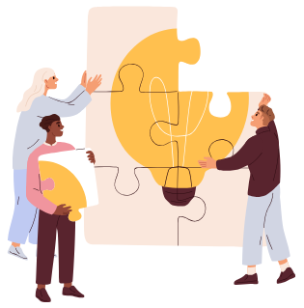
VIEWS International (Belgium) is a European NGO promoting the independence, mobility, and social inclusion of young people with visual impairments. Through Erasmus+ and European Solidarity Corps projects, it supports visually impaired youth in developing autonomy, confidence, and professional skills via volunteering, training, and internships. VIEWS also works to improve the accessibility and inclusiveness of international mobility programmes.
CuBu Foundation (Bulgaria), established in 2006, works in culture, art, inclusive education, and non-formal learning. The organisation designs and manages European projects focused on Universal Design for Learning (UDL), accessibility of spaces and content, and peer learning in youth and adult education. CuBu also delivers diversity, inclusion, and inclusive leadership training and is accredited as an Erasmus+ adult learning provider for 2024–2027.
Slovenian Association of Disabled Students - DŠIS (Slovenia) supports students with disabilities in higher and further education through advocacy and practical services. Its activities include accessible transportation, personal assistance, counselling, and guidance on academic and career pathways. DŠIS also implements non-formal learning activities, youth exchanges, ESC projects, and awareness-raising initiatives promoting inclusion and accessibility.
NGO Sakura (Romania) is a youth organisation founded in 1990 in Bucharest, promoting democratic values, freedom of expression, and youth participation. It operates across education, social inclusion, digital learning, ecology, sports, and international cooperation. In recent years, Sakura has strengthened its focus on inclusive youth work and accessibility-oriented projects through non-formal education and international mobility.
The Polish Association of the Blind - PZN (Poland) is a nationwide organisation founded in 1951, representing nearly 30,000 blind and partially sighted members. Its mission is to support independence, social participation, and vocational inclusion through rehabilitation, education, accessibility, and barrier-free culture. PZN is a member of both the World Blind Union and the European Blind Union.
Peace Volunteering Network - PVN (Albania) promotes peace, democracy, inclusion, and human rights through mobility, intercultural learning, and community development. The organisation delivers trainings, research, and awareness-raising activities at policy, institutional, and community levels. PVN collaborates with civil society, educational institutions, municipalities, and youth centres through a strong international network.
Peace Volunteering Network Norway, established in 2023 in Kristiansand, supports peaceful, democratic, and socially just societies through cross-cultural and cross-sector collaboration. It works with NGOs, municipalities, media, and communities on capacity-building, research, and knowledge exchange. PVN Norway operates within PVN’s international network, ensuring strong global–local cooperation.
Loryhan asbl (Belgium) is a youth organisation based in Botassart-sur-Semois and is officially recognised as a Meeting and Hosting Centre by the Wallonia–Brussels Federation in 2025. For over 20 years, it has hosted international youth exchanges and non-formal learning activities focused on nature, citizenship, sustainability, and social inclusion. The centre hosts around 1,000 young people annually and accommodates up to 52 participants.
Asociația Babilon Travel - ABT (Romania) was founded in 2013 to promote the social inclusion of young people with disabilities. Its activities focus on European values, active citizenship, volunteering, multiculturalism, employability, sustainability, digital skills, and sport as tools for inclusion and well-being. ABT also explores the use of artificial intelligence to enhance accessibility, inclusion, and innovation in youth and educational projects.

The ACT-YOU Project
ACT-YOU is an Erasmus+ project aimed at strengthening inclusive, accessible, and meaningful youth work for young people with fewer opportunities. While youth work is widely recognised as a key space for participation, learning, and empowerment, many youth workers still face concrete challenges when working with young people with disabilities, newcomers, or those facing social, economic, or cultural barriers, often due to a lack of practical guidance and shared tools.
Led by VIEWS International and implemented with partners from seven European countries, ACT-YOU created structured spaces for learning, exchange, and professional development. Through a study visit and an international training course, youth workers and organisations shared experiences, explored inclusive approaches, and strengthened skills in communication, facilitation, accessibility, and cooperation, while fostering stronger European networks.

Why these recommendations
During the implementation of ACT-YOU, recurring barriers and needs emerged across different countries, organisations, and types of activities. Participants identified common challenges related to:
- transport and venue accessibility;
- communication and participation;
- facilitation methods, language barriers, and coordination between partners.
At the same time, they shared concrete solutions, adaptations, and practices that had proven effective in their work with young people with fewer opportunities.
These recommendations build on that collective experience. They translate practical knowledge developed through the project into clear, usable guidance for youth workers, organisations, and project coordinators. Rather than offering fixed rules, they provide reference points and examples that can be adapted to different local realities, supporting better planning, everyday practice, and meaningful participation.


Transport and Venue Accessibility

1. Transport & Mobility
Barriers
Long distances to public transport or project venues can make travel challenging, especially for groups of 20 or more participants. For wheelchair users, public transport may be insufficiently accessible due to limited spaces, inaccessible stations or vehicles, and inter-city coaches that are often unusable. Participants with visual impairments may struggle with orientation, navigating timetables, or travelling independently without sighted guides. Hearing-impaired and sign-language-using participants can face communication difficulties in noisy or foreign-language environments. Assistive devices for blind or visually impaired participants must be carefully transported and insured to avoid damage, which requires planning.
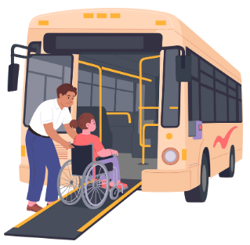
Inclusive Actions
- Ensure sufficient personal assistants, sighted guides, and sign language interpreters to support participants throughout the journey.
- Arrange dedicated or adapted transport for wheelchair users, participants with reduced mobility, and those with visual or hearing impairments when public transport is inaccessible, slow, or unsafe.
- Confirm airline or transport policies for assistive equipment and carry insurance where appropriate to protect essential devices.


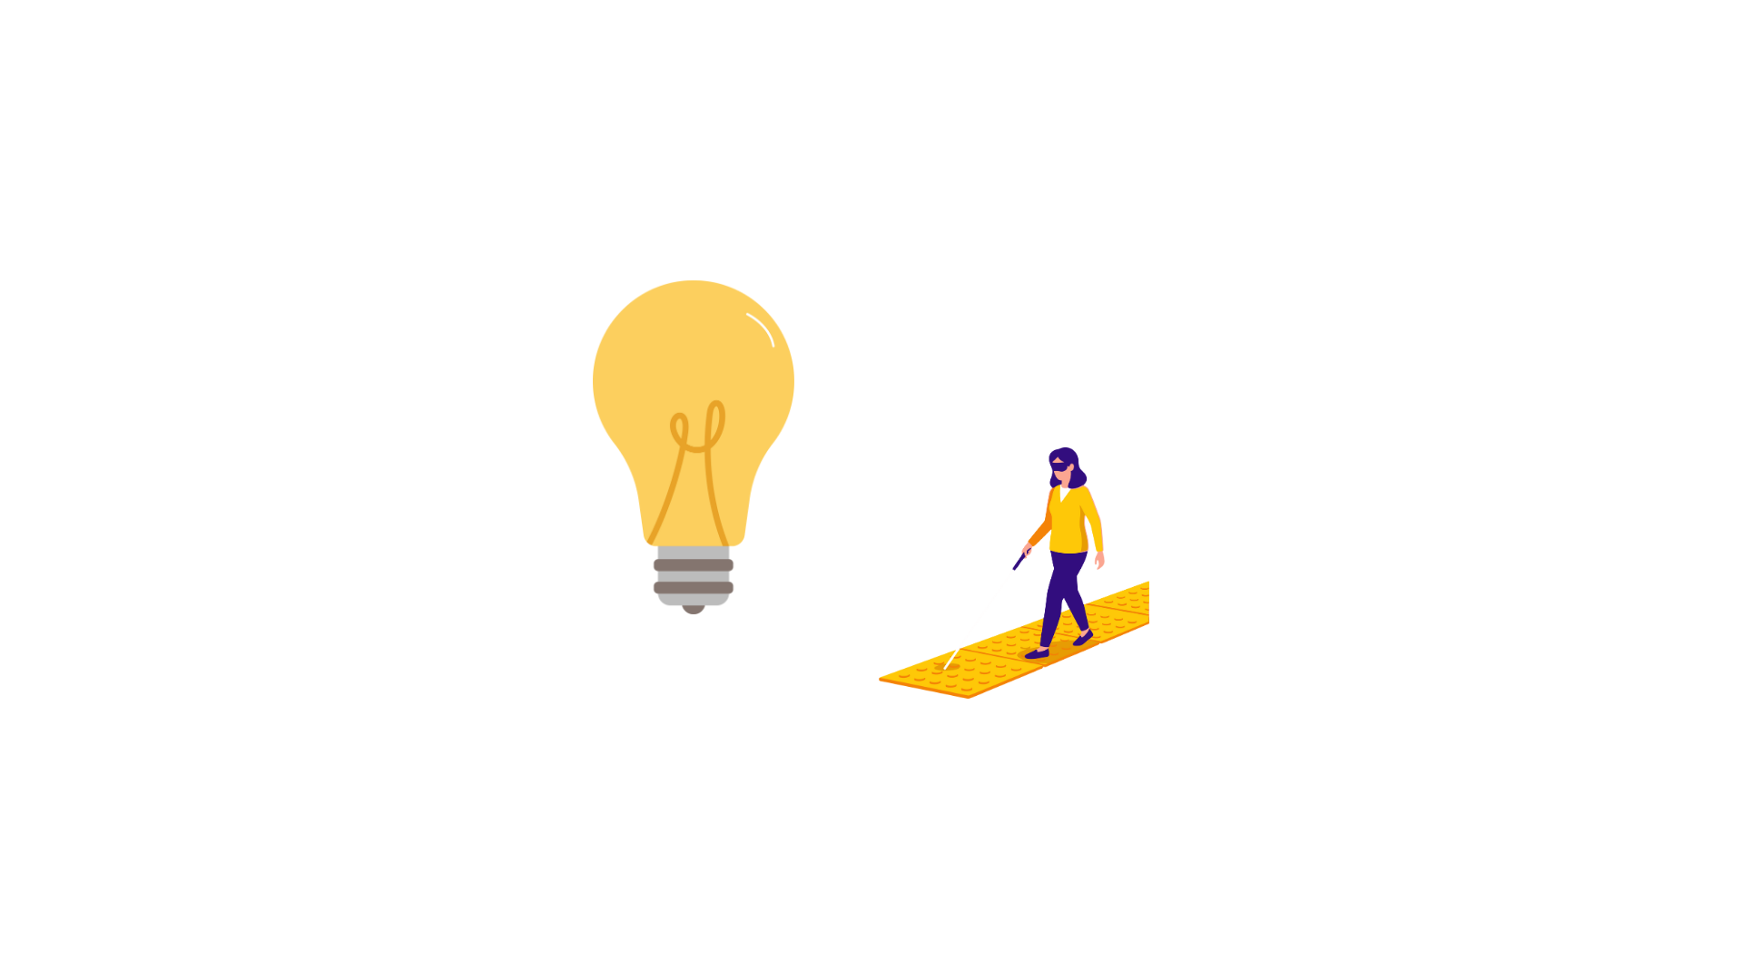
Best Practice: Accessible transport in Slovenia
The Slovenian Association of Disabled Students provides an adapted transport service for students with disabilities who cannot use public transport. While the service mainly supports study-related travel, it can also be used for participation in trainings, events, medical appointments, and similar activities when this does not interfere with academic needs. As inter-city coaches and buses in Slovenia are not accessible for people with mobility impairments, the association arranges accessible transport for international youth events, including transfers from airports, train or bus stations to project venues and transport during activities. In cities, public buses usually allow only one wheelchair user at a time, making group travel difficult; the association’s adapted vans make it possible to transport several participants with disabilities together in a safe and practical way.

2. Venue Accessibility, Accommodation & Daily Living
Barriers
Fully accessible venues for mixed-ability groups are rare. Accessible rooms are often limited, expensive, or insufficient for multiple wheelchair users. Venues may lack mobility features such as wide doors, ramps, lifts, or accessible bathrooms. Visual accessibility features like tactile paths, contrast markings, Braille or large-print signage, and audible lift announcements are uncommon. Blind or visually impaired participants may struggle to navigate cluttered or changing layouts safely, and hearing-impaired participants often do not have access to hearing loops or interpreters. During meals, buffet tables can be too high, circulation space insufficient, and blind or visually impaired participants may struggle with self-service, menu access, and plate orientation. Support dogs require additional planning for documentation, vaccinations, food, and participant allergies.
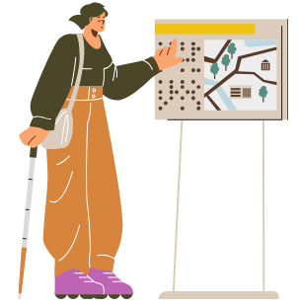
Inclusive Actions
- Conduct an Advance Planning Visit (APV) to verify accessibility, room layouts, mobility routes, lighting, safety procedures, and necessary adaptations.
- Provide orientation and mobility introductions for visually impaired participants, maintain consistent room and furniture layouts, and add temporary large-print or Braille labels where needed.
- Ensure hearing support through installed or portable loops and qualified interpreters, assign sufficient accompanying persons for blind Provide accessible meals with low tables, ample space, and preferably table service; describe menu options and plate layouts to visually impaired participants and assist as needed.

Best Practice: VIEWS’s APVs and accompanying persons training
To ensure smooth participation and safety, VIEWS International conducts Advance Planning Visits (APVs) at all venues to verify that the spaces are fully accessible for persons with disabilities. These visits allow us to check mobility routes, room layouts, lighting, signage, meal areas, and any necessary adaptations well before the activity begins. In addition, VIEWS International prepares accompanying persons ahead of their trip by organising short practical sessions with local visually impaired volunteers. Through these sessions, guides learn essential accompanying techniques, understand what to look out for in different environments, and practise how to describe meals or provide assistance in a safe, respectful, and effective way.

3. Participation and Communication
Barriers
Reaching young people with fewer opportunities can be challenging. Many are hesitant to join activities because they lack confidence, have had fewer positive learning experiences, or prefer to stay within their comfort zones. Those living in rural or isolated areas often have limited access to information and few local structures that can help them learn about opportunities. Communication barriers, such as low digital literacy, limited internet access, or unfamiliarity with international programmes, can further reduce participation. As a result, these young people may not see these activities as “for them,” and may need more encouragement, reassurance, and direct contact to feel safe and motivated to join.
Inclusive Actions
- Use personalised outreach such as phone calls, WhatsApp messages, or visits to local youth spaces to explain that participation is free, supported, and adapted to individual needs. Provide clear, friendly information about what to expect and what support is available.
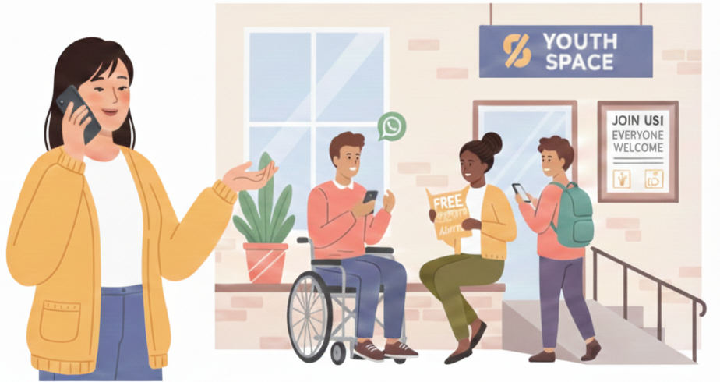
- Collaborate with youth houses, community centres, schools, social services, and small grassroots groups to reach young people in remote or underserved areas and build trust through familiar intermediaries.
- Allocate resources for additional support measures such as assistants, travel help, interpreters, or preparatory meetings, so that young people with fewer opportunities can participate confidently and without financial or logistical barriers.


Best practice: Collaboration with local administration and youth centres, Loryhan
The Loryhan model strengthens youth engagement by establishing structured partnerships between local administrations and youth centres through formal agreements, joint planning, and youth-led activities. The initiative creates an inclusive environment where young people actively contribute to community development thanks to clear cooperation among stakeholders, regular coordination meetings, co-designed activity calendars, shared use of local resources, and open dialogue spaces with decision-makers. Supported by continuous learning and monitoring mechanisms, this model enhances trust between youth and municipalities, increases youth participation in community life, and promotes better coordinated and more sustainable youth services. Loryhan also works in partnership with youth centres and associations in the region and elsewhere, such as the COALA association, which has been organising exchanges at the centre since 2009, and actively collaborates with other European youth organisations through the Erasmus+ networks.

Facilitation and Inclusion

1. Different Levels of Awareness
Barriers
Participants and staff may have varying levels of awareness about inclusion and accessibility. This can result in unequal participation or unintended exclusion if facilitation methods are not adapted to different abilities. Blind or visually impaired participants require tactile, auditory, and descriptive adaptations, while mobility-impaired participants need physically accessible setups. Time requirements for activities may be longer for some participants, and certain sports or recreational activities may require adaptation.
Inclusive Actions
- Get to know participants and their needs through pre-activity assessments, and actively involve them in planning and delivery.
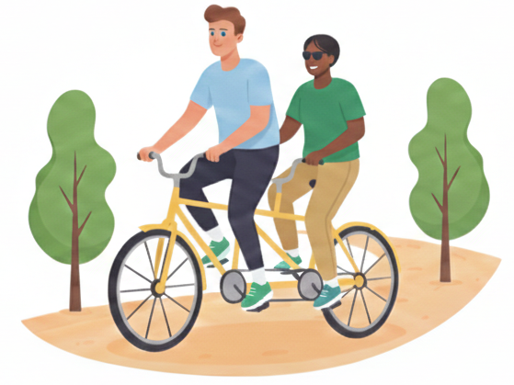
- Provide tactile, auditory, or adapted materials for visually impaired participants, and adapt activities for mobility-impaired participants, including extended time or seated options.
- Include adapted recreational activities such as goalball, sound darts, or tandem cycling, ensuring participants with different abilities can participate meaningfully and independently.


Best Practice: ACT-YOU Peer-lead Accessibility Session
At the beginning of the ACT-YOU training course in Albania, participants took part in an additional session facilitated by two visually impaired participants. The session focused on practical ways to interact inclusively with persons with visual impairments, drawing directly on lived experience. Through concrete demonstrations, the facilitators showed how to accompany a visually impaired person, how to offer support respectfully, and highlighted common do’s and don’ts in everyday interactions. The session also created space for open and respectful dialogue, encouraging participants to ask appropriate questions and better understand different ways of navigating daily life and participation. This peer-led approach helped increase awareness, reduce uncertainty, and promote more confident, respectful, and inclusive behaviour among participants.

Best Practice: The Big Thing Guidelines
As a practical resource for making activities more accessible, the Big Thing (TBT) Guidelines for trainers and for institutions, developed by Arkhe (Spain), Zavod ODTIZ (Slovenia), and VIEWS International (Belgium), offer tested recommendations drawn from real project experience. They provide trainers, youth workers, and organisations with concrete strategies to adapt learning spaces, materials, and group processes so that all participants, including those with disabilities and/or fewer opportunities, can take part meaningfully. Rather than fixed instructions, the guidelines serve as an inspiring framework to support more inclusive and equitable activities.

2. Language Barriers
Barriers
Differences in language or communication methods can hinder participation and understanding. Non-verbal or artistic activities may be required to ensure comprehension beyond language.

Inclusive Actions
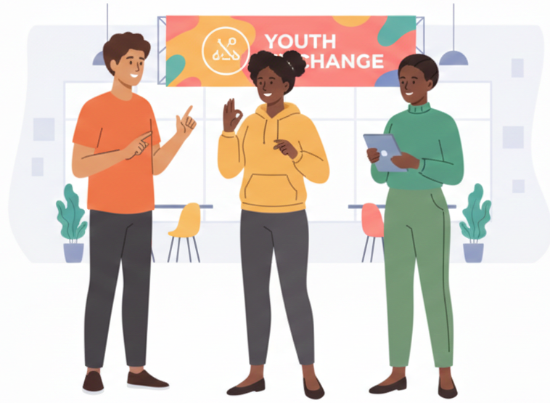
- Provide translators or interpreters as needed, including sign language interpreters for deaf participants.
- Integrate non-verbal, artistic, or sensory-based activities to foster understanding beyond spoken language.
- Ensure all materials for blind or visually impaired participants are in accessible electronic formats with descriptive explanations of graphics.

3. Accessibility of the Activities
Barriers
Even when the venue is accessible, the activities themselves may not be. Many workshops rely on visual content, fast-paced instructions or movement-based tasks that exclude participants with different abilities. Accessible formats, such as tactile graphics, audio descriptions, large print, or clear captions, are often missing.
Events can also become inaccessible when facilitation methods are not adapted. Blind participants may need more time to explore tactile materials; wheelchair users may struggle with activities requiring mobility or height-based access; deaf participants may lack interpreters or cannot follow discussions in echoing or noisy spaces.
When accessibility requirements are not coordinated in advance, such as the need for extra wheelchairs, interpreters, or adapted sports equipment, participants may be unintentionally left out of the activity.
Inclusive Actions
- Adapt activities by providing accessible materials (tactile graphics, large print, audio descriptions), using non-visual or non-auditory methods, and selecting inclusive games such as goalball, sound darts, or seated tasks suitable for mobility-impaired participants.
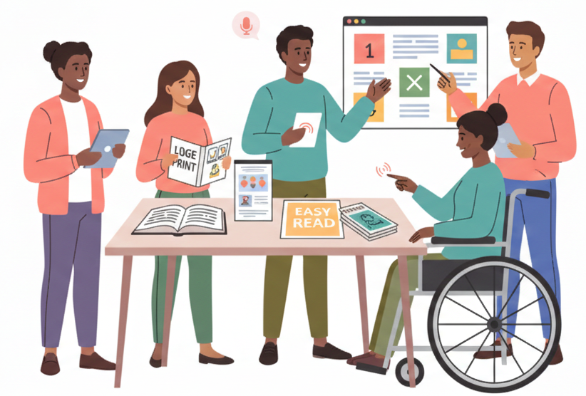
- Plan activity accessibility early: agree on who supplies which assistive devices, prepare mobile ramps or extra wheelchairs when needed, and structure sessions with more time for tactile exploration or interpretation.

- Deliver events with flexible facilitation: use clear instructions, integrate alternative formats, ensure sign language interpreters are present where required, and design tasks that support independence while offering assistance only when needed.
Best Practice: KYP – Know Your Participant Approach
The KYP (Know Your Participant) approach ensures accessibility happens where it matters most—during the activity itself. Even in an accessible venue, people can be unintentionally excluded by how activities are designed, explained, or paced. KYP encourages organisers to learn participants’ individual needs in advance, rather than guessing or relying on standard solutions. Through short participation forms, brief pre-event conversations, and respectful data handling, facilitators can provide the right support, such as accessible materials, activity setups that consider physical, sensory, and emotional needs, flexible facilitation with clear instructions, and support offered when needed while respecting independence. By treating participants as experts in their own experience, KYP creates activities where everyone can take part fully and comfortably.

Partnership and Cooperation

1. Partner Engagement and Reliability
Barriers
Building and maintaining strong, inclusive partnerships can be challenging. Some organisations may initially participate actively but become less engaged over time. Differences in understanding of accessibility and inclusion can lead to inconsistent approaches, while staff turnover or organisational changes may disrupt collaboration. Without deliberate planning, the co-design and meaningful involvement of persons with disabilities can be overlooked, weakening inclusivity, accessibility and the strength of the partnership.
Inclusive Actions
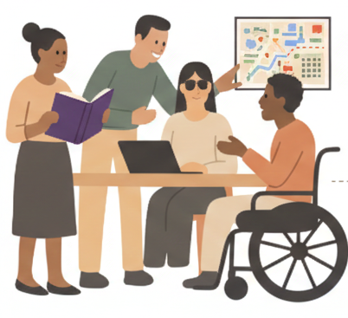
- Involve partners and persons with disabilities directly in designing, planning, and implementing activities, embedding inclusion principles at every stage, and organise partnership-building activities such as workshops, joint trainings, team-building exercises, co-creation sessions, and collaborative brainstorming to foster trust, shared understanding, and a sense of joint ownership.
- Foster commitment and shared responsibility by clarifying partner contributions to inclusion and co-design, defining roles and expectations, and promoting joint decision-making and collective ownership of project outcomes.

- Provide guidance, accessible materials, and necessary support such as interpreters, assistants, or adapted resources, enabling all partners to participate fully in co-design and partnership-building activities.
Best practice: ABT’s partnership building activities
The growing number of active NGOs offers many opportunities for international cooperation, but experience shows that effective and reliable partnerships require time and intentional investment. In response to this, Asociatia Babilon Travel (ABT) has developed a strong practice in partner engagement through the organisation of annual Partnership Building Activities (PBAs). Over the past three years, these activities have focused on meeting partner organisations face to face, creating time to exchange working methods, explore best practices, and identify shared values and objectives. The PBAs enable partners to better understand each other’s capacities, communication styles, and long-term visions, laying a solid foundation for future collaboration. As a result, the quality and reliability of partnerships have improved significantly, leading to more transparent communication, more meaningful cooperation, and stronger, more sustainable joint project outcomes.

2. Coordination and Collaborative Work
Barriers
Long-term projects require careful coordination to ensure that inclusion measures are implemented consistently and effectively. Unclear deadlines, conflicting schedules across organisations, and differences in partner capacity or experience in applying inclusion can result in uneven participation and support for persons with disabilities. Without structured communication and clearly defined operational processes, accessibility arrangements, such as transport, assistants, or adapted materials, may be delayed or insufficient.
Inclusive Actions
- Establish a clear coordination framework with defined timelines, responsibilities for task delivery, and monitoring mechanisms, ensuring that each partner knows their operational role in implementing inclusion measures.
- Use collaborative tools such as shared calendars, project management platforms, and progress trackers to monitor deadlines, resource allocation, and the implementation of accessibility measures across all activities.
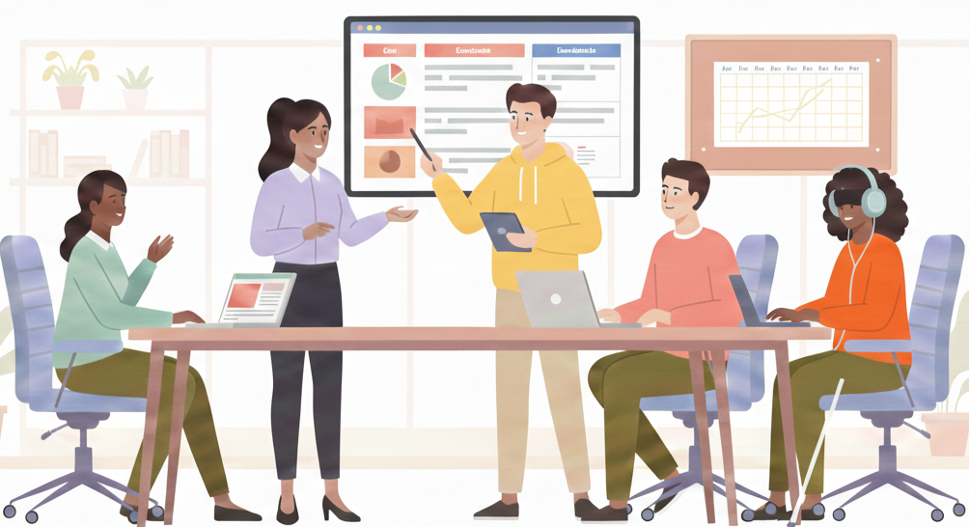
- Schedule regular check-ins or coordination meetings to identify gaps, redistribute tasks if needed, and ensure consistent application of inclusion strategies throughout the project.

Best practice: DSIS’s Inclusive Youth Exchange
The Slovenian Association of Disabled Students, with partners from Croatia, Hungary, and Austria, organised a 13-day travelling youth exchange across four countries, addressing significant coordination and accessibility challenges. The exchange brought together young people with diverse disabilities and support needs, with each location focusing on a different inclusion-related theme. Partner organisations arranged accessible accommodation and activities in their countries, while transport was coordinated jointly. The programme covered employment in Slovenia, culture in Croatia, sports in Hungary, and access to higher education in Austria, combining workshops, visits, and inclusive activities adapted to participants’ abilities. Careful preparation, regular online coordination, and understanding participants’ individual needs were key to success. Despite challenges in securing accessible accommodation and transport, partners shared resources, knowledge, and assistive solutions, ensuring full participation and demonstrating the importance of flexibility and close coordination in multi-country projects.

Policy Implications

Embedding inclusion at a systemic level
Project-based initiatives can demonstrate inclusive practice, but long-term impact depends on supportive policy frameworks. Embedding accessibility and inclusion within funding mechanisms, youth work standards, and education and training systems helps ensure that inclusive approaches are applied consistently and sustained beyond individual projects. In this context, accessibility should be understood as a core quality requirement for youth work, rather than an optional or additional measure.

Policy recommendations
- Integrate clear accessibility and inclusion criteria into youth project funding guidelines, selection processes, and evaluation frameworks;
- Require and adequately fund Advance Planning Visits for activities involving participants with disabilities or complex support needs;
- Develop European-level quality benchmarks for accessible events, venues, learning environments, and materials;
- Ensure stable and dedicated funding for assistive technologies, interpretation, personal assistance, and accessibility-related training;
- Support structured peer learning and exchange on inclusive practice through Erasmus+, SALTO, and Council of Europe platforms;
- Embed universal design and intersectional approaches within youth work education, training curricula, and accreditation systems.

CONCLUSIONS
Inclusive youth work does not happen by chance; it requires awareness, planning, cooperation, and a willingness to adapt to real needs. The recommendations presented in these guidelines are grounded in the practical experience of youth workers and organisations involved in the ACT-YOU project, and reflect challenges and solutions encountered across different contexts, and discussed during the partnership’s shared activities. They highlight that accessibility and inclusion are integral to youth work and must be considered at every stage, from preparation and partnership building to facilitation and follow-up.
Rather than providing fixed answers, these guidelines offer practical reference points that can support reflection, decision-making, and continuous improvement. By encouraging flexible, context-sensitive approaches and shared responsibility among partners, they aim to strengthen everyday practice and promote more meaningful participation of young people with fewer opportunities. Ultimately, the guidelines invite youth workers and organisations to keep learning from experience, from young people themselves, and from each other, contributing to more accessible and responsive youth work across Europe.

